*A Minor**Project Report On*

“Bus Ticket Booking System”

For the Partial Fulfilment of the 5th Semester Practical of Bachelor of Computer Application of Veer Narmad South Gujarat University, Surat

Bachelor of Computer Application [B.C.A] Semester – V

By

*Harshad Kumhar* Exam No:- 2990

Guided By

*[Prof.Swati Khandelwal]*

DEVIBA INSTITUTE OF COMPUTER APPLICATION, SABARGAM Year: 2024-2025

|  |  |
| --- | --- |
|  | **AMBABA COMMERCE COLLEGE,MANIBA INSTITUTE OF BUSINESS MANAGEMENT & DEVIBA INSTITUTE OF COMPUTER APPLICATION,**  **SABARGAM (Self Finance)**  **At. Sabargam, Po.Niyol, Tal. Choryasi, Surat-394 325.**  Managed By Shree Dakshin Gujarat Shikshan Samaj, Kumbharia |

Certificate

This is to certify that Harshad Kumhar Roll no____229_____ Exam Seat Number: ____2990_____________have/has satisfactorily presented their Project work entitled**”** Bus Ticket Booking System”as partial fulfillment of requirements for **5th *Semester– B.C.A.,*** during the academic Year 2024-2025.

**Guide Name: Swati Khendelwal**

**Dr. Falguni M Thakkar**

**Principal**

**Ambaba Commerce College, MIBM & Deviba Institute of Computer Application, Sabargam**

**Date : 22/10/2024**

**Place : Sabargam, Surat**

**Acknowledgment**

We would like to extend our deepest gratitude to everyone who contributed to the development of the **Bus Ticket Booking System**.

I also add complex functionalities behind the scenes, such as the Booking, My Profile, and Ticket Management pages. I ensured that all systems run smoothly and efficiently, from dynamic ticket pricing to secure data management.

Finally, we are grateful to our users, whose feedback and support have been invaluable in refining this system. Your input has helped us create a platform that not only meets but exceeds expectations.

Thank you all for your unwavering support and collaboration in making the **Bus Ticket Booking System** asuccess.

We extend our sincere and heartfelt thanks to our esteemed guide, **Prof.Swati Khandelwal**, for providing us with the right guidance and advice at crucial junctures and for showing us the right way.

We extend our sincere thanks to our respected head of the division **Dr. Rajesh Savaliya**, for allowing us to use the facilities available

|  |  |  |
| --- | --- | --- |
| **INDEX** | | |
| **Chapter**  **No** | **Description** | **Page no** |
| **1** | **Introduction** | **7-15** |
|  | 1.1 Existing System | **8** |
|  | 1.2 Limitation of Existing System | **8** |
|  | 1.3 Proposed System Introduction | **10** |
|  | 1.4 Project Profile | **12** |
|  | 1.5 Scope of Proposed System | **13** |
|  | 1.6 Objective of Proposed System | **14** |
|  | 1.7 System Environment Description | **15** |
|  |  |  |
| **2** | **Detail Description of Technology Used** | **16-24** |
|  | 2.1 What is React JS | **16** |
|  | 2.2 Why React JS | **17** |
|  | 2.3 What is Node JS | **18** |
|  | 2.4 Why Node JS | **19** |
|  | 2.5 What is Express JS | **20** |
|  | 2.6 Why Express JS | **21** |
|  | 2.7 What is MongoDB | **21** |
|  | 2.8 Why MongoDB | **22** |
|  | 2.9 HTML | **22** |
|  | 2.10 Java Script | **23** |
|  | 2.11 Bootstrap and CSS | **23-24** |
|  |  |  |
| **3.** | **System Planning (Analysis)** |  |
|  | 3.1 Analysis All Factors | **25-26** |
|  | 3.2 Ris Analysis | **27** |
|  | 3.3 Project Analysis | **28** |
|  | 3.4 Process | **29-30** |
|  |  |  |
| **4** | **System Design** |  |
|  | 4.1 Task Dependency Diagram | **31** |
|  | 4.2 Data Flow Diagram(DFD)/UML | **32-35** |
|  |  |  |
|  |  |  |
| **5** | **User Interface** |  |
|  | 5.1 Admin Side | **36-41** |
|  | 5.1.1 Admin Login | **36** |
|  | 5.1.2 Admin Registration | **36** |
|  | 5.1.4 Admin Home Page | **37** |
|  | 5.1.3 Admin Profile Page | **38** |
|  | 5.1.5 Admin Bus Details Page | **38** |
|  | 5.1.6 Admin Passanger Details Page | **39** |
|  | 5.1.7 Admin Payment Details Page | **39** |
|  | 5.1.8 Admin User Details Page | **40** |
|  | 5.1.9 Admin Add BusPage | **40** |
|  | 5.1.10 Admin Update Bus Page | **41** |
|  | 5.1.11 Admin Delete Bus Page | **41** |
|  |  |  |
|  |  |  |
|  | 5.2 Client Side | **42-53** |
|  | 5.2.1 Client Login | **42** |
|  | 5.2.2 Client Registration | **42** |
|  | 5.2.4 Client Home Page | **43** |
|  | 5.2.3 Client Profile Page | **44** |
|  | 5.2.5 Client Forget Password Page | **44** |
|  | 5.2.6 Client Search Tikcet Page | **45** |
|  | 5.2.7 Client Available Bus Page | **45** |
|  | 5.2.8 Client Pssanger Details Page | **46** |
|  | 5.2.9 Client Seat Layout Page | **46** |
|  | 5.2.10 Client Payment Page | **47** |
|  | 5.2.11 Client Ticket Layout Page | **47** |
|  | 5.2.12 Client Download Ticket Page | **48** |
|  | 5.2.13 Client Cancel Ticket Page | **48** |
|  | 5.2.14 Client Adverties Page | **49** |
|  | 5.2.15 Client Number Growing Page | **49** |
|  | 5.2.16 Client FAQ Page (Frequent Ask Question ) | **50** |
|  | 5.2.17 Client Bus Service Page | **51** |
|  | 5.2.18 Client Privacy & Policy Page | **51** |
|  | 5.2.19 Client Terms & Conditions Page | **52** |
|  | 5.2.20 Client Review Page | **52** |
|  | 5.2.21Client About Us Page | **53** |
|  | 5.2.22 Client Contact Us Page | **53** |
|  |  |  |
|  | 5.3 Visitor Side | **54-58** |
|  | 5.3.1 Visitor Home Page | **54** |
|  | 5.3.2 Visitor Adverties Page | **55** |
|  | 5.3.3 Visitor Review Page | **55** |
|  | 5.3.4 Visitor Terms & Condition Page | **56** |
|  | 5.3.5 Visitor Peivacy Policy Page | **56** |
|  | 5.3.6 Visitor FAQ Page | **57** |
|  | 5.3.7 Visitor Service Page | **57** |
|  | 5.3.8 Visitor Contact Us Page | **58** |
|  | 5.3.9 Visitor About Us Page | **58** |
|  |  |  |
| **6** | **Conclusion** | **69** |
|  |  |  |
| **7** | **Bibliography** | **60** |
|  |  |  |
|  |  |  |

**INTRODUCTION**

Here's an introduction to GSRTC (Gujarat State Road Transport Corporation):

Gujarat State Road Transport Corporation (GSRTC) is a state-owned road transport corporation in India, headquartered in Gandhinagar, Gujarat. Established in 1960, GSRTC provides bus transportation services to millions of passengers daily, connecting various cities, towns, and villages within Gujarat and neighboring states.

Purpose:

The purpose of this documentation is to provide a comprehensive guide for:

1. Passengers: To understand how to use the system to book bus tickets.

2. Bus Operators: Manage bus schedules, fares, and bookings.

3. System Administrators: To configure and maintain the system.

Scope:

The Bus Ticket Booking System includes the following features:

1. User Registration and Login

2. Bus Schedule Search and Booking

3. Seat Selection and Ticket Confirmation

4. Payment Gateway Integration

5. Booking History and Cancellation

6. Bus Operator Dashboard and Reporting

7. System Administration and Configuration

Technical Requirements:

1. Web Browser: Google Chrome, Mozilla Firefox, or Microsoft Edge

2. Operating System: Windows, macOS, or Linux

3. Database: MongoDB

4. Server: Nodejs

5. Programming Language: React Js,html,css, javascript

By following this documentation, users can effectively utilize the Bus Ticket Booking System to book bus tickets online, while bus operators can manage their bookings and schedules efficiently.

**1.1 EXISTING SYSTEM :**

* The Bus Ticket Booking System is a web-based application designed to facilitate the online booking of bus tickets.
* The system allows passengers to search for available bus schedules, book tickets, and make payments online.
* This documentation provides an overview of the system's features, functionality, and technical requirements.
* The existing system refers to the system that has been followed till now.
* The existing system requires more computational time, more manual calculations, and the complexity involved in Selection of features is high.
* The other disadvantages are lack of security of data, Deficiency of Data accuracy, Time consumption, etc.
* To avoid all these limitations and make the work more accurate the system needs to be computerized.
* Here in the Electronic bus ticketing, a detailed study of the existing system is carried out `along with all the steps in system analysis.

**1.2 LIMITATION OF EXISTING SYSTEM:**

Here are some limitations of existing systems in bus ticket booking documentation:

• It is less user-friendly.

• It is difficult to maintain the record.

• Not in reach of distance.

• This process is so much time-consuming and requires more workforce.

• not get data in real-time.

• pdf receipts not generated.

1. **Manual Errors**: Manual booking systems are prone to errors, such as incorrect passenger information, wrong seat assignments, or calculation mistakes.

2. **Time-Consuming**: Manual booking systems can be time-consuming, leading to long queues and wait times for passengers.

3. **Limited Accessibility**: Existing systems may not be accessible online or through mobile devices, making it difficult for passengers to book tickets remotely.

4. **No Real-Time Updates:** Existing systems may not provide real-time updates on seat availability, schedules, or cancellations.

5. **Lack of Payment Options:** Existing systems may not offer multiple payment options, causing inconvenience to passengers.

6. **Poor User Experience**: Existing systems may have a poor user interface, making it difficult for passengers to navigate and book tickets.

7. **Inefficient Reporting**: Existing systems may not provide efficient reporting and analytics, making it difficult for bus operators to track sales, revenue, and passenger trends.

8. **Security Concerns**: Existing systems may not have robust security measures, putting passenger data at risk.

9. **Scalability Issues**: Existing systems may not be able to handle a large volume of bookings, leading to system crashes or slow performance.

10. **Lack of Integration**: Existing systems may not integrate with other systems, such as fleet management or customer relationship management systems.

These limitations highlight the need for a more efficient, user-friendly, and automated bus ticket booking system.

Keeping all limitations in mind the college management system is designed and comes in use all over colleges.

**1.3 PROPOSED SYSTEM :**

* **INTRODUCTION :**

Here's an introduction to a proposed ticket booking system:

System Name: Bus Ticket Booking System

Overview: Easy Ride is a user-friendly, efficient, and scalable online ticket booking system designed to simplify the process of booking bus tickets. Our system aims to provide a seamless experience for passengers, while also streamlining operations for bus operators.

**Key Features:**

1. **User-Friendly Interface**: Easy-to-use website and mobile app for passengers to search, book, and manage tickets.

2. **Real-Time Updates**: Instant availability and scheduling information, ensuring accurate bookings.

3. **Secure Payment Gateway:** Multiple payment options, including credit/debit cards, net banking, and e-wallets.

4. **Seat Selection:** Interactive seat map for passengers to choose their preferred seats.

5. **Loyalty Program:** Rewards and discounts for frequent travelers.

6. **Reporting and Analytics:** Comprehensive dashboard for bus operators to track sales, revenue, and passenger trends.

7. **Integration**: Compatibility with existing fleet management and customer relationship management systems.

8. **Mobile Ticketing:** Passengers can access their tickets on their mobile devices, eliminating paper tickets.

9. **Customer Support:** 24/7 phone, email, and live chat.

Benefits:

1. **Convenience**: Easy booking and management of tickets.

2. **Time-Saving:** Quick and efficient booking process.

3. **Increased Sales**: User-friendly interface and loyalty program encourage repeat business.

**1.4 Project Profile :**

**Project Title**: BUS TICKET BOOKING SYSTEM

**Project Type**: Web Application

**Project Team:** 1 Member

**Technology Used**:

* Front-End:-
* Back-End:- Node.js, Express.js
* Database:- MongoDB

**Project Manager:** Kumhar Harshad

**Developers**: Kumhar Harshad

**Designers**: Kumhar Harshad

**Testing Team:** ---------

**Time Duration:** 2 Month

**Submitted by**: -------------------

**Submitted to**: Department of Computer Science, Deviba Institute of Computer Application, Surat-395010

**1.5 Scope of A Proposed System :**

The scope of a proposed system for bus ticket booking could include:

1. **Online Booking:** Allow customers to book tickets online through a website or mobile app.

2. **Seat Selection**: Enable customers to select their preferred seats.

3. **Payment Gateway:** Integrate a secure payment gateway for easy transactions.

4. **Schedule Management**: Display bus schedules and fares.

5. **Ticket Confirmation**: Send confirmation emails or SMS for booked tickets.

6. **Cancellation and Refund:** Allow customers to cancel tickets and process refunds.

7. **User Accounts:** Offer user registration and login for booking history and preferences.

8. **Reporting and Analytics:** Provide insights on bookings, revenue, and customer behavior.

9. **Integration with Operators**: Integrate with bus operators for real-time inventory and schedules.

10. **Customer Support**: Offer support for booking-related queries and issues.

This scope can be expanded or modified based on specific requirements and user needs.

**1.6 Objective of the Proposed System :**

The objectives of a proposed system for bus ticket booking could include:

1. **Convenience:** Provide a user-friendly platform for customers to book bus tickets easily.

2. **Time-saving**: Reduce the time spent on booking tickets by eliminating the need for physical visits to bus stations.

3. **Increased Accessibility:** Allow customers to book tickets from anywhere, at any time.

4. **Improved Efficiency:** Automate the booking process, reducing manual errors and wait times.

5. **Enhanced Customer Experience:** Offer personalized services, such as preferred seat selection and loyalty programs.

6. **Increased Revenue**: Attract more customers through online booking, resulting in higher sales for bus operators.

7. **Real-time Information:** Provide up-to-date schedules, fares, and availability to customers.

8. **Reduced Costs:** Minimize operational costs by reducing the need for physical ticketing infrastructure.

9. **Data Analysis:** Collect and analyze customer data to improve services and marketing strategies.

10. **Scalability:** Design a system that can adapt to growing demand and expanding bus routes.

These objectives can be tailored to specific needs and goals of the bus ticket booking system.

**1.7 System Environment Description**

You want to describe the system environment for a bus ticket booking system. Here's a possible description:

**System Environment:**

The bus ticket booking system operates in a web-based environment, accessible through various devices connected to the internet. The system consists of:

**Hardware Components:**

- Servers (for hosting the website and database)

- Database management systems (for storing and managing data)

- Network infrastructure (for connecting servers and devices)

- Client devices (computers, laptops, mobile phones, tablets)

**Software Components:**

- Operating Systems (Windows, Linux, etc.)

- Web server software (npm ,nodejs)

- Programming languages (React js, Angular js, etc.)

- Database management systems (MongoDB, etc.)

- Web application framework (Html, CSS Bootstrap, Javascript, etc.)

- Payment gateway integration

**Network Environment:**

- Internet connectivity (wired or wireless)

- Network protocols (HTTP, HTTPS, etc.)

- Firewalls and security measures (for protecting data and preventing unauthorized access)

**User Environment:**

- End-users (customers, bus operators, administrators)

- User interfaces (web browsers, mobile apps)

- User roles and access levels (different levels of access for customers, operators, and administrators)

This system environment description provides a general overview of the hardware, software, network, and user components involved in the bus ticket booking system.

**2. Detail Description of Technology Used**

**2.1 What is React JS :**

* React is a **JavaScript** library created by **Facebook**
* React is a **User Interface** (UI) library
* React is a tool for building **UI components**

**React JS** is a popular JavaScript library used for building user interfaces, particularly single-page applications where you want your web app to load quickly and provide a smooth user experience. It was developed by Facebook and is now maintained by Facebook and a community of developers.

Here are some key points about React JS:

1. **Component-Based**: React is all about components. Components are like small, reusable pieces of code that define how a part of the user interface (UI) should look and behave. Each component can have its own logic and state (data that can change over time).
2. **Virtual DOM:** React uses a Virtual DOM (Document Object Model) to improve performance. When something changes in the UI, React creates a virtual copy of the DOM, updates only the necessary parts, and then efficiently updates the real DOM. This process is faster than traditional methods where the entire DOM is updated.
3. **Declarative:** With React, you describe what you want the UI to look like, and React takes care of updating it when your data changes. This makes it easier to predict how your UI will look at any given point.
4. **JSX Syntax:** React uses JSX, a syntax extension that looks similar to HTML. JSX allows you to write HTML-like code within your JavaScript, making it easier to create and visualize UI components.
5. **Single-Page Applications (SPAs):** React is often used to build SPAs, where the application loads a single HTML page and dynamically updates the content as the user interacts with it, rather than loading new pages from the server.
6. **Unidirectional Data Flow:** React has a unidirectional data flow, meaning that data flows in one direction—from parent components to child components. This makes it easier to understand how data is being passed around in your application.
7. **Ecosystem:** React has a large ecosystem with many libraries and tools that complement it, such as React Router for handling navigation and Redux for state management.

8**. Cross-Platform:** React can be used to build not just web applications but also mobile applications using React Native, a framework that allows you to build native mobile apps using React.

React is widely used in the industry because of its flexibility, performance, and

ease of use, making it a go-to choice for developers building modern web

applications

**2.2 Why is React JS :**

* ReactJS is a popular framework for web development because it offers many advantages, including:
* **Performance :**

ReactJS uses a JavaScript **virtual DOM** that's faster than the standard DOM, which improves app performance.

* **Reusable components :**

ReactJS's reusable components make it easier to build, test, and maintain applications.

* **Flexibility :**

ReactJS is highly flexible and can be easily migrated to other frameworks and libraries.

* **Ease of use :**

ReactJS is easy to learn and has a large developer community. It's similar to HTML and JavaScript and has fewer concepts than other languages.

* **Simplified scripting :**

ReactJS makes the scripting environment process simpler and easier to maintain.

* **Search engine friendly :**

ReactJS is search engine friendly.

* **Modules :**

ReactJS's modules and valid data make it easier to manage larger apps.

* **React Native :**

React Native is the mobile app development counterpart to ReactJS, making it easy to develop apps for iOS and Android.

* **Unique React hooks :**

React Hooks is a feature in ReactJS 16.8 that allows JavaScript writers to add states and other functionality to function components.

**2.4 What is Node JS :**

**Node.js** is a powerful and widely used runtime environment that allows you to run JavaScript code on the server side. Unlike traditional JavaScript, which typically runs in the browser, Node.js lets developers use JavaScript for backend development, enabling full-stack JavaScript applications.

* Node.js is an open source server environment
* Node.js is free
* Node.js runs on various platforms (Windows, Linux, Unix, Mac OS X, etc.)
* Node.js uses JavaScript on the server
* Node.js files have extension ".js"
* Node.js can generate dynamic page content
* Node.js can create, open, read, write, delete, and close files on the server
* Node.js can collect form data
* Node.js can add, delete, and modify data in your database

**Key Features of Node.js:**

1. **JavaScript on the Server:** o Node.js allows you to write server-side applications in JavaScript, using the same language as your front-end (React, for example). This creates a more consistent development experience and allows full-stack JavaScript development.

2. **Non-Blocking I/O:** o Node.js is designed to handle multiple tasks simultaneously using non-blocking, event-driven architecture. This means it can handle many connections at once without waiting for any one of them to complete before moving on to the next. This makes Node.js very efficient for handling high traffic and real-time applications.

1. **Single-Threaded but Highly Scalable:** o Node.js operates on a single thread using an event loop, which allows it to manage many connections efficiently. This single-threaded nature makes Node.js lightweight and fast while being capable of scaling up for larger applications.
2. **NPM (Node Package Manager):** o Node.js comes with NPM, a vast library of open-source packages that can be easily integrated into your project. These packages provide pre-built functionality, saving time and effort during development. For example, you can use Express.js (a web application framework)for building APIs, Mongoose for working with MongoDB, and so on.
3. **Real-Time Applications**: o Node.js is particularly well-suited for building real-time applications like chat apps, online games, or collaborative tools where many users interact with the server simultaneously and expect immediate responses.
4. **JSON Support:** o Since JavaScript Object Notation (JSON) is a common format for data exchange on the web, Node.js naturally excels in handling JSON, making it easier to build APIs and work with data.
5. **Cross-Platform:** o Node.js can run on various operating systems, including Windows, Linux, and macOS, making it versatile for different development environments.

8. **Microservices and API Development:** o Node.js is often used to build microservices and RESTful APIs due to its lightweight and efficient nature. It’s great for creating the back-end logic that powers modern web and mobile applications.

**2.5 Why Node JS :**

**Node.js** uses asynchronous programming!

A common task for a web server can be to open a file on the server and return the content to the client.

Here is how PHP or ASP handles a file request:

1. Sends the task to the computer's file system.
2. Waits while the file system opens and reads the file.
3. Returns the content to the client.
4. Ready to handle the next request.

Here is how Node.js handles a file request:

1. Sends the task to the computer's file system.
2. Ready to handle the next request.
3. When the file system has opened and read the file, the server returns the content to the client.

Node.js eliminates the waiting and simply continues with the next request.

Node.js runs single-threaded, non-blocking, asynchronous programming, which is very memory efficient.

**2.6 What is Express JS :**

* **Express.js** is a fast, flexible, and minimalist web framework for Node.js. It’s effectively a tool that simplifies building web applications and APIs using JavaScript on the server side.
* Express is an open-source that is developed and maintained by the Node.js foundation.
* Express.js offers a robust set of features that enhance your productivity and streamline your web application.
* It makes it easier to organize your application’s functionality with middleware and routing.
* It adds helpful utilities to Node HTTP objects and facilitates the rendering of dynamic HTTP objects.

**Key Features of Express**

1. **Middleware and Routing**: Define clear pathways (routes) within your application to handle incoming HTTP requests (GET, POST, PUT, DELETE) with ease. Implement reusable functions (middleware) to intercept requests and create responses, adding functionalities like authentication, logging, and data parsing.
2. **Minimalistic Design**: Express.js follows a simple and minimalistic design philosophy. This simplicity allows you to quickly set up a server, define routes, and handle HTTP requests efficiently. It’s an excellent choice for building web applications without unnecessary complexity.
3. **Flexibility and Customization**: Express.js doesn’t impose a strict application architecture. You can structure your code according to your preferences. Whether you’re building a RESTful API or a full-fledged web app, Express.js adapts to your needs.
4. **Templating Power**: Incorporate templating engines like Jade or EJS to generate dynamic HTML content, enhancing user experience.
5. **Static File Serving**: Effortlessly serve static files like images, CSS, and JavaScript from a designated directory within your application.
6. **Node.js Integration**: Express.js seamlessly integrates with the core functionalities of Node.js, allowing you to harness the power of asynchronous programming and event-driven architecture.

**Applications of Express**

Express.js empowers you to construct a wide array of web applications. Here are some captivating examples:

* **RESTful APIs:**Develop robust APIs that adhere to the REST architectural style, enabling communication with other applications and front-end interfaces.
* **Real-time Applications:**Leverage Express.js’s event-driven nature to create real-time applications like chat or collaborative editing tools.
* **Single-Page Applications (SPAs):** Craft SPAs that fetch and update content dynamically on the client-side, offering a seamless user experience.

**2.7 Why Express JS :**

* Express is a user-friendly framework that simplifies the development process of Node applications.
* It uses JavaScript as a programming language and provides an efficient way to build web applications and APIs.
* With Express, you can easily handle routes, requests, and responses, which makes the process of creating robust and scalable applications much easier.
* Moreover, it is a lightweight and flexible framework that is easy to learn and comes loaded with middleware options.
* Whether you are a beginner or an experienced developer, Express is a great choice for building your application.

**2.8 What is MongoDB :**

* MongoDB is a document database. It stores data in a type of JSON format called BSON.
* If you are unfamiliar with JSON, check out our [JSON tutorial](https://www.w3schools.com/js/js_json.asp).
* A record in MongoDB is a document, which is a data structure composed of key value pairs similar to the structure of JSON objects.
* MongoDB is a document database and can be installed locally or hosted in the cloud.

**2.9 Why MongoDB :**

* SQL databases are considered relational databases.
* They store related data in separate tables.
* When data is needed, it is queried from multiple tables to join the data back together.
* MongoDB is a document database which is often referred to as a non-relational database.
* This does not mean that relational data cannot be stored in document databases.
* It means that relational data is stored differently.
* A better way to refer to it is as a non-tabular database.
* MongoDB stores data in flexible documents.
* Instead of having multiple tables you can simply keep all of your related data together. This makes reading your data very fast.
* You can still have multiple groups of data too. In MongoDB, instead of tables these are called collections.

**2.10 What is HTML :**

HTML is the standard markup language for creating Web pages.

• Structure of Webpages

• Hyperlinks

• Media Embedding

• Forms and Input Handling

• Semantic Elements

• Compatibility

• Extensibility with CSS and JavaScript

• Document Object Model (DOM)

What is HTML?

* HTML stands for Hyper Text Markup Language
* HTML is the standard markup language for creating Web pages
* HTML describes the structure of a Web page
* HTML consists of a series of elements
* HTML elements tell the browser how to display the content
* HTML elements label pieces of content such as "this is a heading", "this is a paragraph", "this is a link", etc.

**Why Used?**

When creating a website, HTML is the foundation that holds all the content and design elements together.

**2.11 JAVA SCRIPT :**

**JavaScript** is a powerful programming language used to create dynamic and interactive content on websites. It is an essential part of web development, working alongside HTML (which structures content) and CSS (which styles content) to enhance the functionality of web pages. JavaScript allows you to build interactive features like forms, games, animations, and more.

• Client-Side Scripting

• Event Handling

• Asynchronous Programming

• Wide Browser Support

* JavaScript is the world's most popular programming language.
* JavaScript is the programming language of the Web.
* JavaScript is easy to learn.
* This tutorial will teach you JavaScript from basic to advanced.
* JavaScript is the **Programming Language** for the Web.
* JavaScript can update and change both **HTML** and **CSS.**
* JavaScript can **calculate**, **manipulate** , and **validate** data.

**2.12 What is CSS :**

CSS stands for **Cascading** Style Sheets

• Styling and Layout

• Customizable Appearance

• Animation and Transition Effects

• Cross-Browser Compatibility

• Scalable and Reusable

* CSS describes how HTML elements are to be displayed on screen, paper, or in other media
* CSS saves a lot of work. It can control the layout of multiple web pages all at once
* External stylesheets are stored in CSS files

**What is Bootstrap :**

* Bootstrap is a free front-end framework for faster and easier web development
* Bootstrap includes HTML and CSS-based design templates for typography, forms, buttons, tables, navigation, modals, image carousels, and many others, as well as optional JavaScript plugins
* Bootstrap also gives you the ability to easily create responsive designs

**3. System Planning (Analysis)**

**3.1 Analysis of all factors :**

To analyze the various factors involved in the Bus Ticket Booking System project, we need to consider different aspects that contribute to the success and functionality of the project.

These factors can be categorized into several key areas:

* 1. **Project Requirements**
* Functional Requirements: These include the essential features and functions that the system must provide, such as room booking, user registration, payment processing, room availability checking, and user feedback management.
* Non-Functional Requirements: These relate to the system's performance, scalability, security, and usability. Examples include the speed of processing bookings, system availability, data security, and ease of use.
  1. **Technology Stack**
* Front-End: The project uses React.js for the front-end, which provides a responsive and dynamic user interface. Bootstrap CSS is used for styling, ensuring the design is modern, responsive, and easy to maintain.
* Back-End: The back-end is built using Node.js and Express.js, offering a robust and scalable server-side environment that handles requests, manages sessions, and processes business logic.
* Database: MongoDB is used as the database, providing a flexible, scalable, and high-performance solution for managing the hotel's data, such as bookings, user information, and room details.
  1. **User Experience**
* User Interface Design: The project emphasizes a user-friendly interface with clear navigation, attractive design, and responsive elements that adapt to different screen sizes.
* Accessibility: The system should be accessible to a broad audience, including people with disabilities, by following best practices in web accessibility.
* User Feedback: Gathering user feedback and implementing improvements based on this feedback is crucial for enhancing the system and meeting user needs.
  1. **Security**
* Data Protection: Protecting guest information, such as personal details and payment information, is paramount. The system must implement strong encryption, secure authentication, and data access controls.
* Compliance: The project should comply with relevant data protection regulations, such as GDPR, to ensure that user data is handled legally and ethically.
* Regular Security Audits: Conducting regular security audits helps to identify and fix vulnerabilities, keeping the system secure against potential threats.
  1. **Performance**
* Scalability: The system should be able to handle increasing numbers of users and bookings as the Ticket grows. This involves optimizing the back-end and database for high performance.
* Load Handling: The system should be tested to ensure it can handle peak loads, such as during holiday seasons when booking activity is high.
* Speed and Efficiency: Page load times and transaction processing speeds should be optimized to provide a smooth user experience.
  1. **Project Management**
* Timeline: The project should have a clear timeline with milestones for different phases, such as development, testing, and deployment.
* Resource Allocation: Proper allocation of resources, including developers, designers, and testers, is crucial to meet project deadlines and maintain quality.
* Risk Management: Identifying potential risks, such as delays, technical challenges, or scope changes, and having contingency plans in place is important for successful project completion.
  1. **System Integration**
* Third-Party APIs: The system may need to integrate with third-party APIs for payment processing, email notifications, and other services.
* Interoperability: Ensuring that the system can easily integrate with other software used by the hotel, such as accounting or CRM systems, is important for smooth operations.
* Testing: Thorough testing is necessary to ensure that all integrated components work together seamlessly without conflicts or errors.
  1. **Maintenance and Support**
* Ongoing Maintenance: After deployment, the system will require regular maintenance to fix bugs, update features, and ensure security.
* User Support: Providing customer support for users, including troubleshooting, handling inquiries, and offering guidance, is essential for user satisfaction.
* Documentation: Comprehensive documentation for the system's code, features, and user guidelines is necessary to support maintenance and user onboarding.
  1. **Cost and Budget**
* Development Costs: Estimating the costs associated with development, including labor, tools, and technologies.
* Operational Costs: Ongoing costs for server hosting, domain registration, and any third-party services or APIs.
* Return on Investment (ROI): Analyzing the potential ROI by considering how the system will improve efficiency, increase bookings, and enhance guest satisfaction.
  1. **Future Scalability and Upgrades**
* Room for Expansion: The system should be designed with future growth in mind, allowing for easy addition of new features, modules, or additional properties if the hotel chain expands.
* Technology Upgrades: Keeping the system up-to-date with the latest technologies and best practices is essential for long-term success.

**3.2 Risk Analysis :**

1. **Technical Risks**

* Integration Issues: Potential problems integrating React.js, Node.js, Express.js, and MongoDB. Mitigation: Use standardized APIs and thorough testing.
* Performance Problems: Risk of slow response times under heavy load. Mitigation: Conduct load testing, optimize performance, and use scalable cloud services.
* Security Vulnerabilities: Risk of data breaches. Mitigation: Implement strong security measures, including encryption and regular audits.

**2. Operational Risks**

* Development Delays: Unforeseen delays due to technical or team issues. Mitigation: Develop a realistic timeline, use agile methods, and monitor progress regularly.
* Resource Availability: Key team members may become unavailable.
* Mitigation: Cross-train team members and maintain thorough documentation.
* Budget Overruns: Costs may exceed the initial budget. Mitigation: Monitor expenses, maintain a contingency fund, and reassess budget regularly.

**3. User-Related Risks**

* User Adoption: Users may be reluctant to adopt the new system. Mitigation: Engage users early, gather feedback, and provide training.
* Usability Issues: Potential usability challenges. Mitigation: Conduct user testing and focus on intuitive design.
* Data Migration Challenges: Risk of data loss or inaccuracies during migration. Mitigation: Test migration thoroughly and validate data accuracy.

**4. Regulatory and Compliance Risks**

* Data Privacy Regulations: Non-compliance with data protection laws. Mitigation: Follow regulations and consult legal experts.
* Industry Standards: Not meeting industry standards. Mitigation: Adhere to standards and best practices.

**5. External Risks**

* Technology Changes: Rapid tech advancements may affect system components. Mitigation: Stay updated with technology trends and design for flexibility.
* Third-Party Dependencies: Risks from third-party services (e.g., payment gateways). Mitigation: Choose reliable providers and have contingency plans

**3.3 Project Analysis**

|  |  |  |  |  |
| --- | --- | --- | --- | --- |
| Task Description | Priority | Estimated Effort | Status | Completion % |
| Collect requirements | High | 2 days | Completed | 100% |
| Analyze gathered information | High | 3 days | Completed | 100% |
| Define project scope | Medium | 2 days | Completed | 100% |
| Identify risks | High | 1 days | Completed | 100% |
| Determine project modules | Medium | 2 days | Completed | 100% |
| Design basic interface | High | 4 days | Completed | 100% |
| Design database schema | High | 3 days | Completed | 100% |
| Develop module logic | High | 5 days | Completed | 100% |
| Implement database connectivity | Medium | 2 days | Completed | 100% |
| Integrate modules | High | 7 days | Completed | 100% |
| Validate input controls | Medium | 2 days | Completed | 100% |
| Test overall system and connectivity | High | 4 days | In Progress | 50% |
| Testing By Client | High | 1 days | Not Started | 0% |

**3.4 Process:**

Certainly! Here’s an overview of the software development process, broken down into key stages: Analysis, Design, Coding, Testing, and Maintenance.

* + 1. **Analysis**

Objective: To understand and define the problem or requirements of the project.

Activities:

* Requirement Gathering: Collect detailed requirements from stakeholders, including users, clients, and team members.
* Feasibility Study: Assess the practicality of the proposed solution, including technical, financial, and operational aspects.
* Requirements Analysis: Analyze and document the requirements to create a clear understanding of what needs to be developed.

Outcome: A comprehensive requirement specification document that outlines what the system needs to achieve.

* + 1. **Design**

Objective: To create a blueprint for the system based on the requirements gathered.

Activities:

* System Architecture Design: Define the overall structure of the system, including hardware, software, and network components.
* Database Design: Develop the schema and relationships for data storage.
* Interface Design: Create wireframes and design the user interface, focusing on user experience and interaction. Outcome: Design specifications and models, including system architecture diagrams, database schemas, and UI mockups.
  + 1. **Coding**

Objective: To develop the actual software based on the design specifications.

Activities: Code Development: Write the source code for the application, following coding standards and best practices.

* Integration: Combine different modules and ensure they work together as intended.
* Version Control: Use version control systems to manage code changes and collaborate with team members. Outcome: Functional software that aligns with the design specifications, ready for testing.
  + 1. **Testing**

Objective: To ensure the software functions correctly and meets the specified requirements.

Activities:

• Unit Testing: Test individual components or units of code to verify their correctness.

• Integration Testing: Ensure that combined modules or systems work together properly.

• System Testing: Evaluate the complete system to ensure it meets all requirements and functions as expected.

• User Acceptance Testing (UAT): Validate the software with endusers to confirm it meets their needs and expectations. Outcome: Identified and resolved issues, resulting in a stable and reliable software product.

* + 1. **Maintenance**

Objective: To support and improve the software after deployment.

Activities:

• Bug Fixing: Address and resolve any issues or defects that arise post-release.

• Updates and Enhancements: Implement updates to improve functionality, performance, or security based on user feedback and changing requirements.

• Performance Monitoring: Continuously monitor the system to ensure it performs well and scales with user demands. Outcome: Ongoing support and improvements to keep the software relevant, functional, and efficient over time

1. **System Design**

**4.1 TASK DEPENDENCY DIAGRAM :**

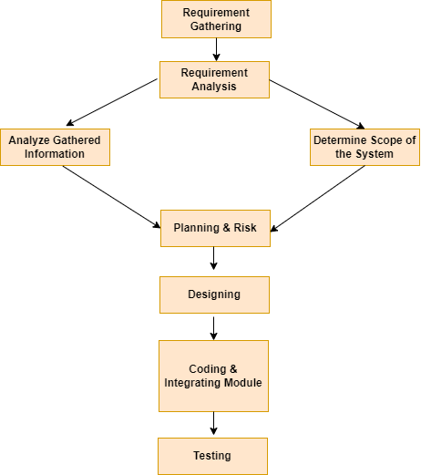

**4.2 Data Flow Diagram(DFD)/UML :**

0 level dfd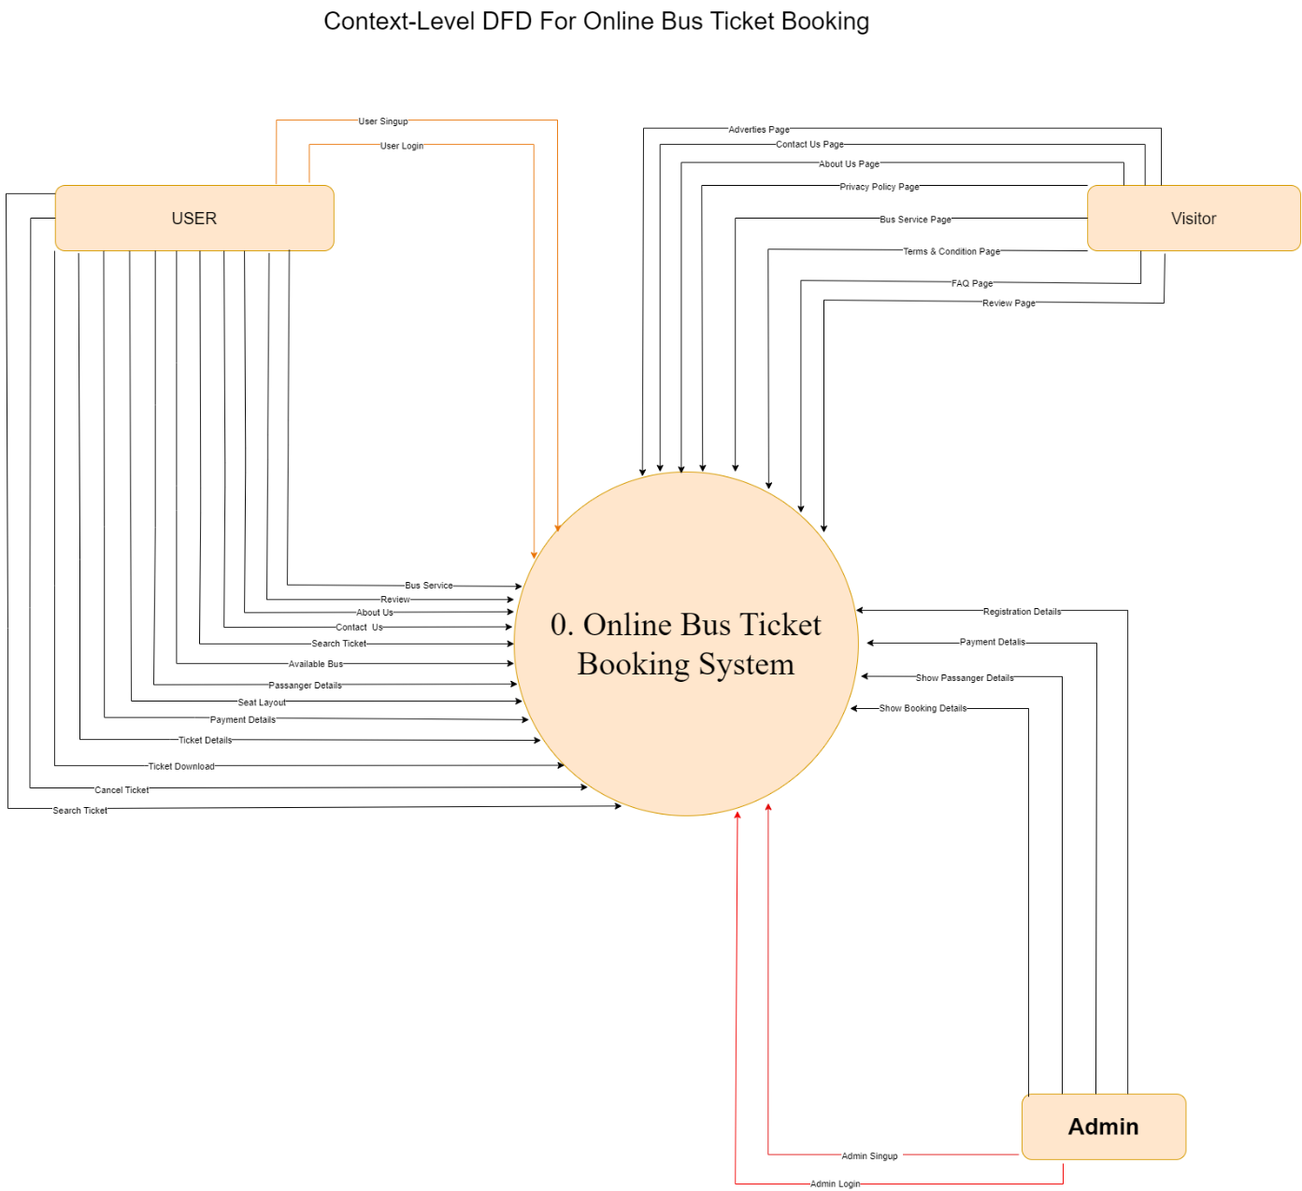

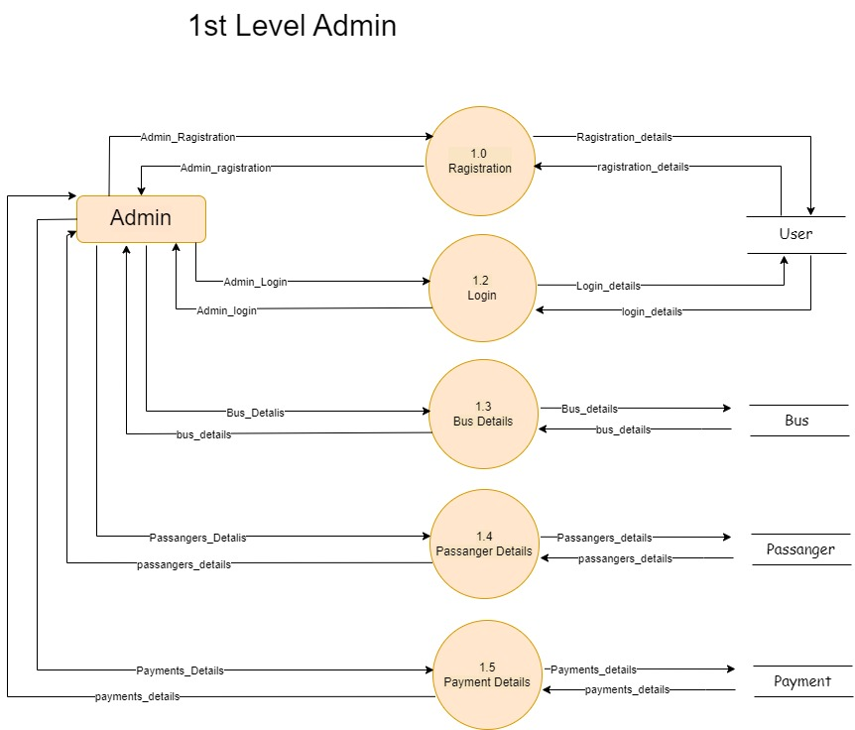

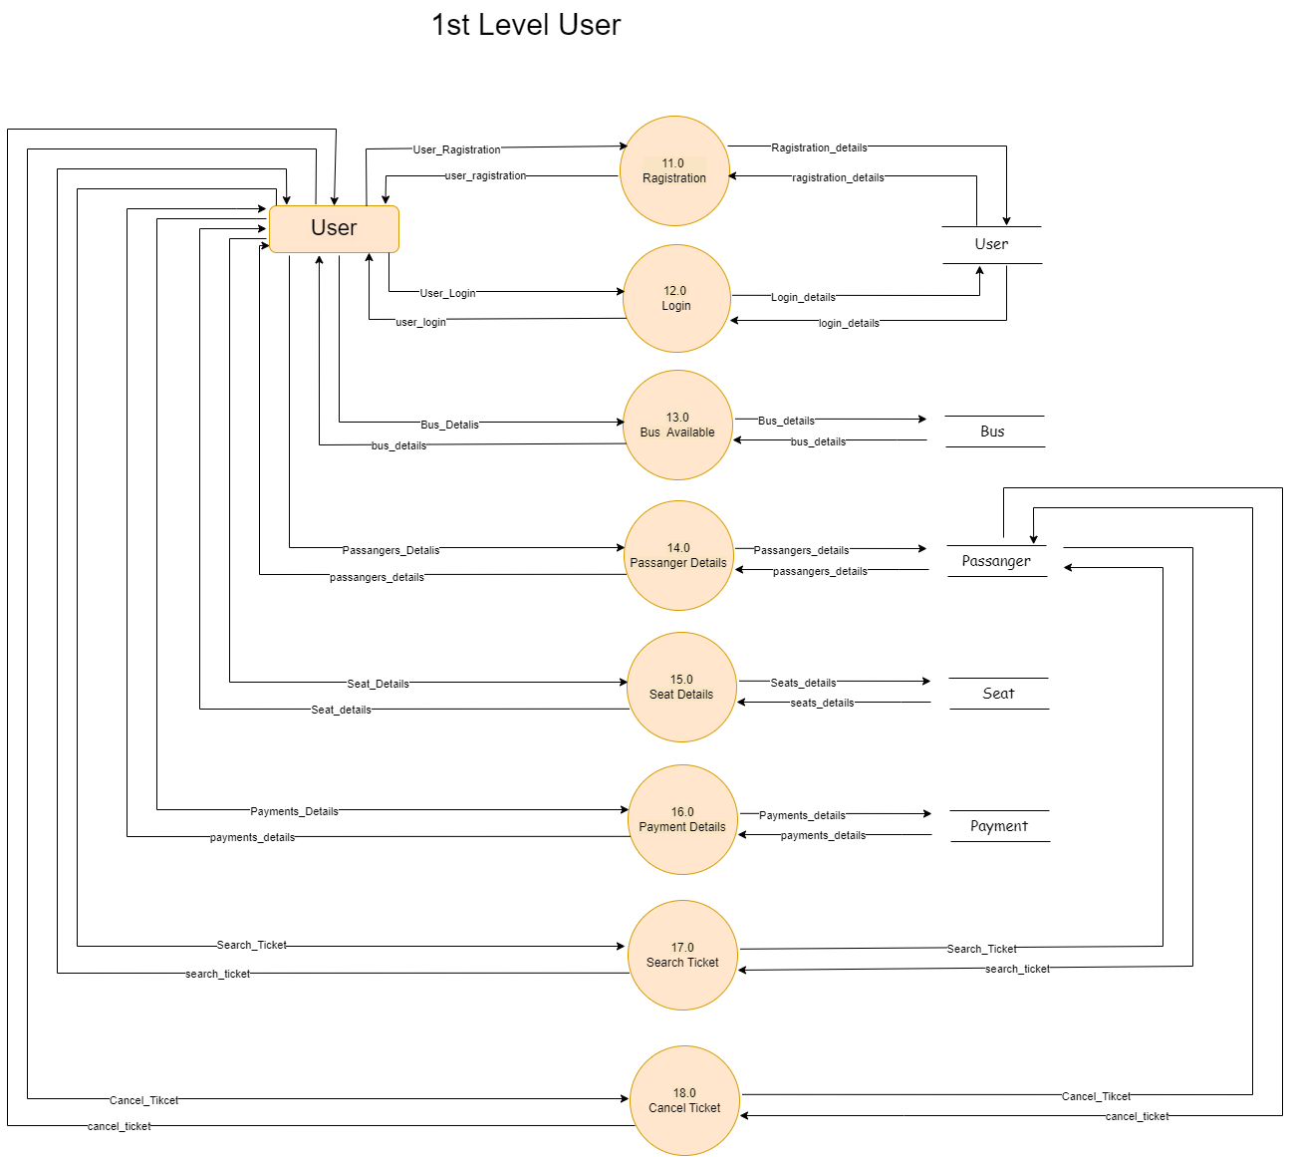

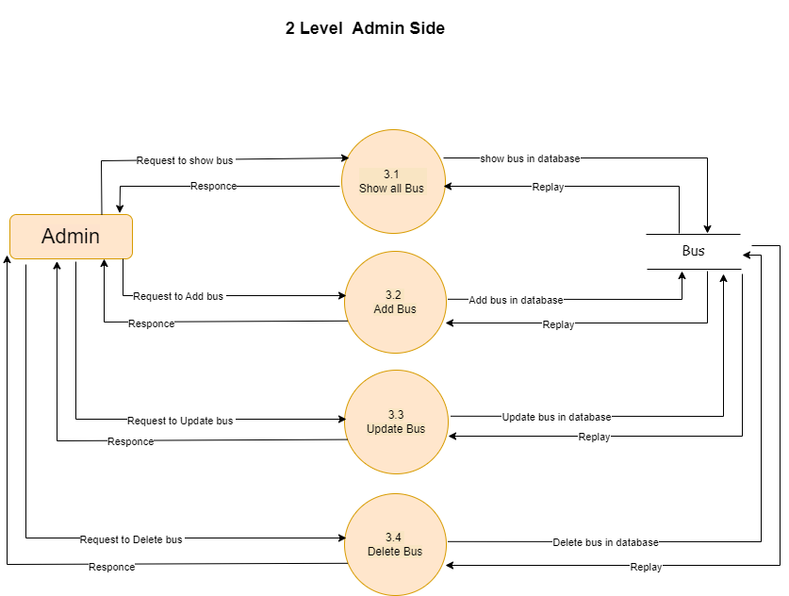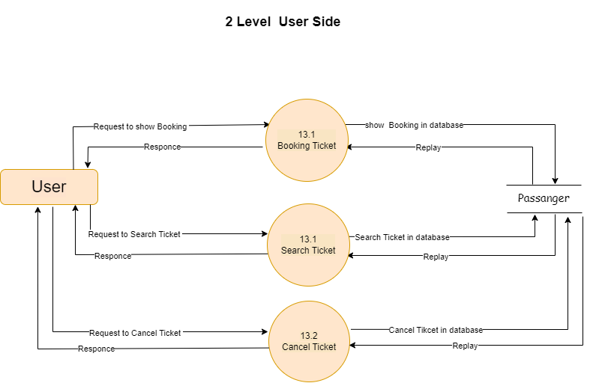

1. **User Interface**

**5.1Admin Side**

5.1.1 Admin Login

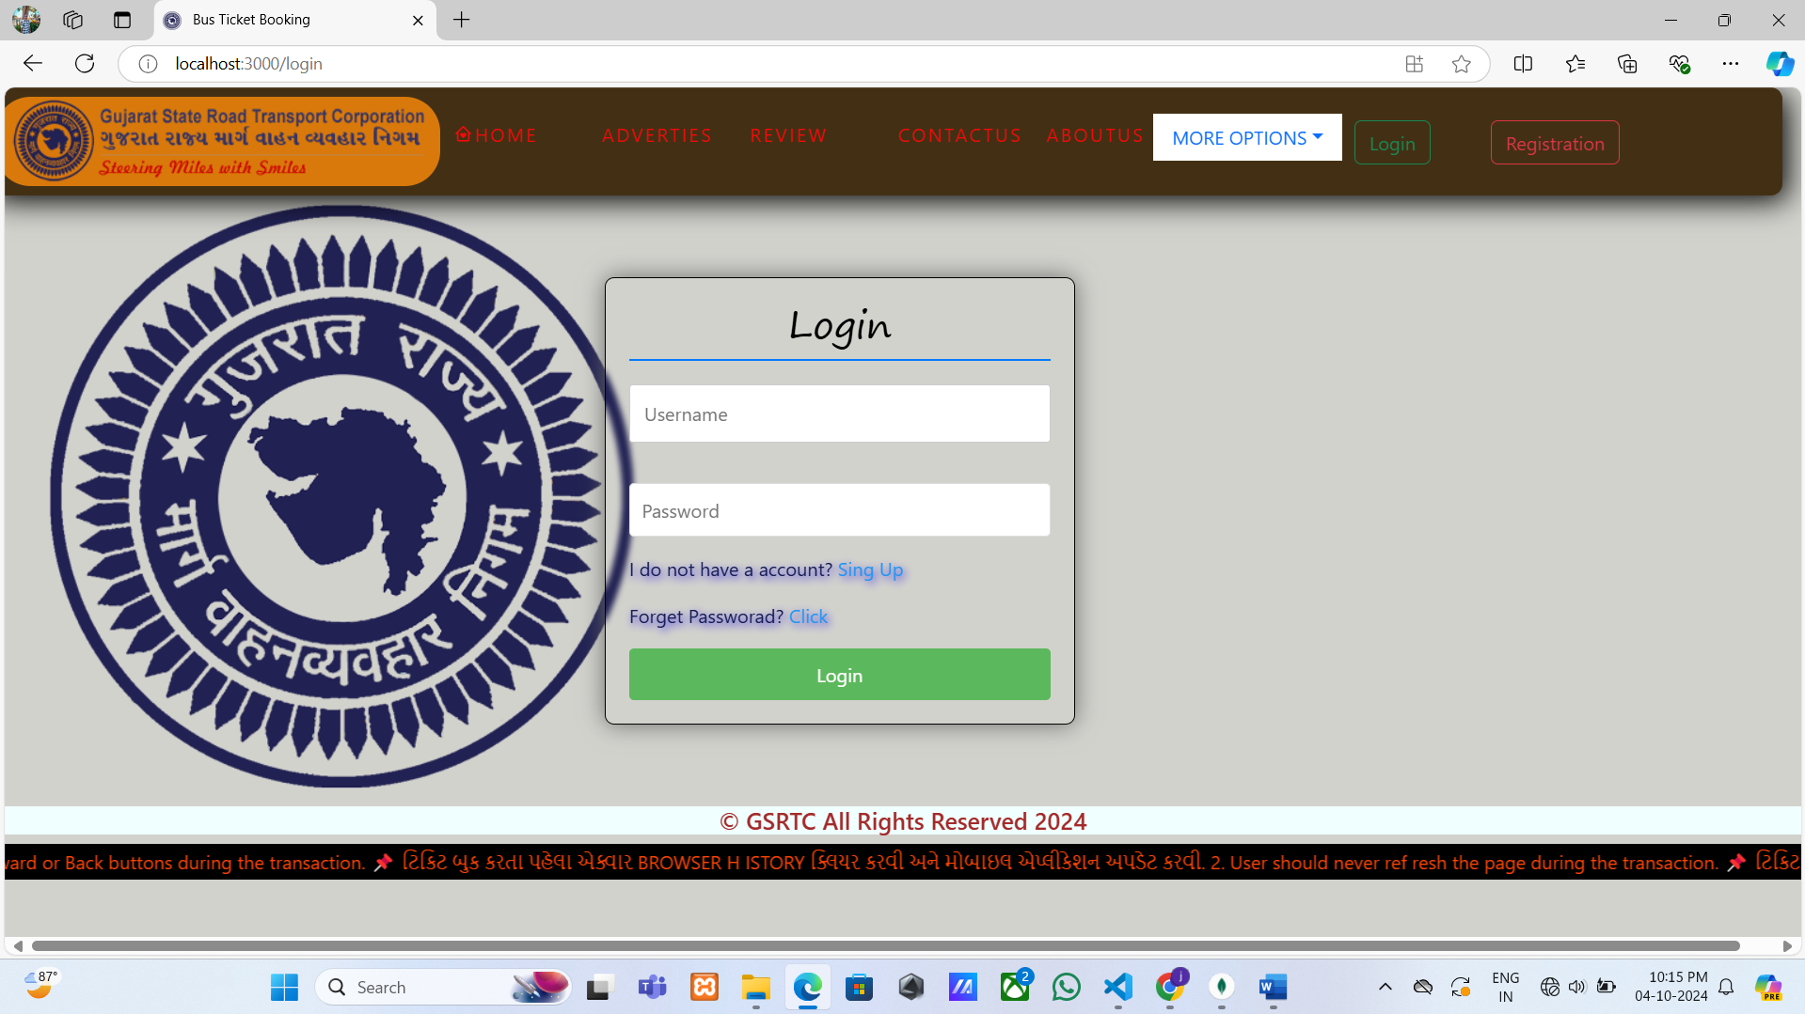

5.1.2 Admin Registration

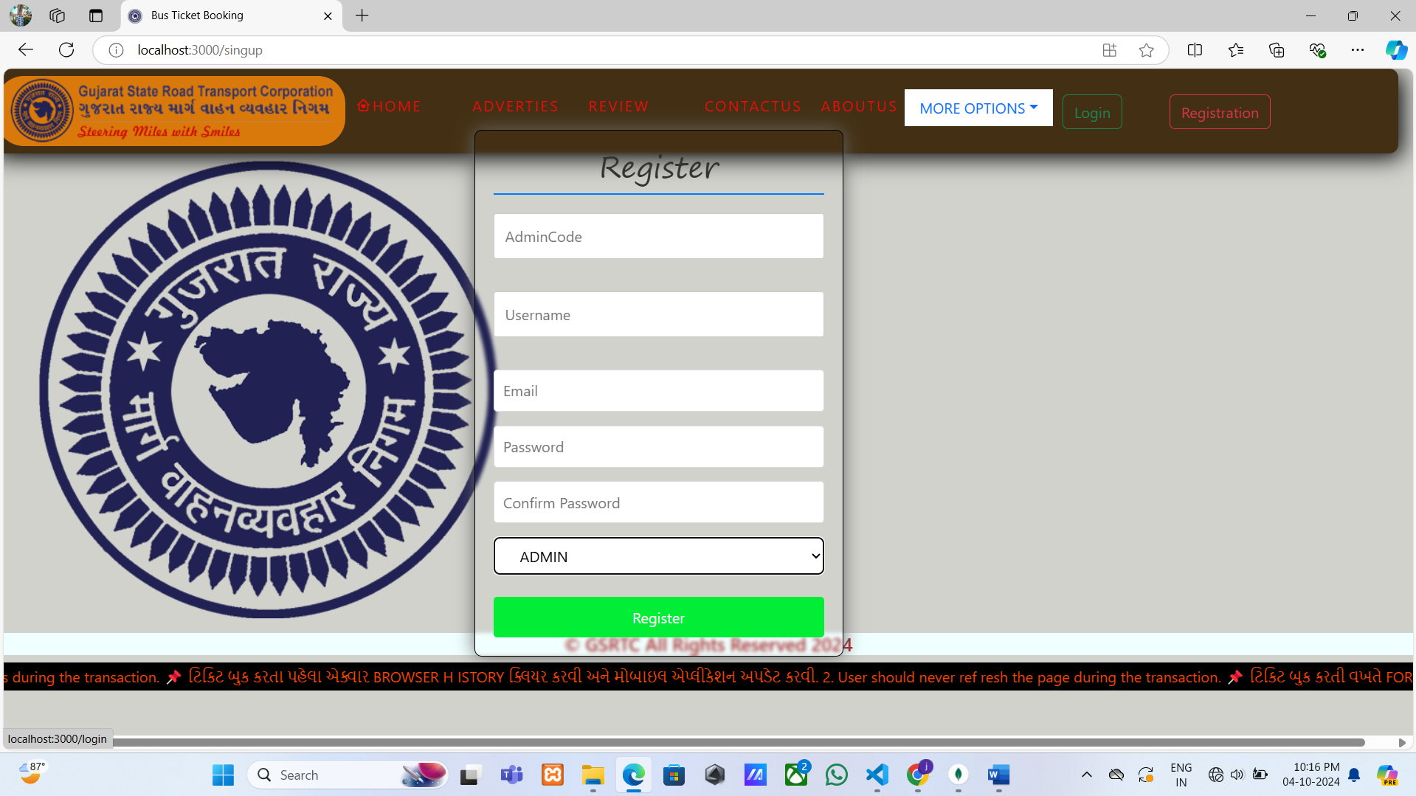

5.1.3 Admin Home Page

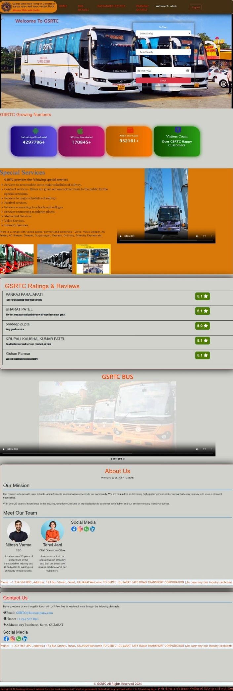

5.1.4. Admin Profile Page

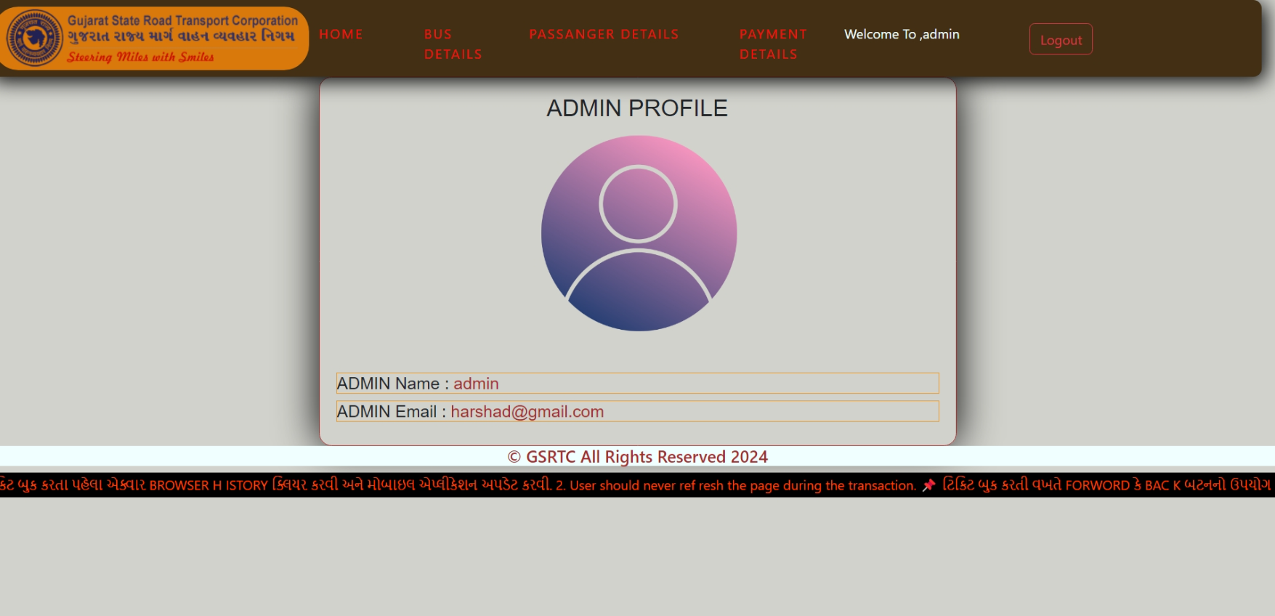

5.1.5 Admin Bus Details Page

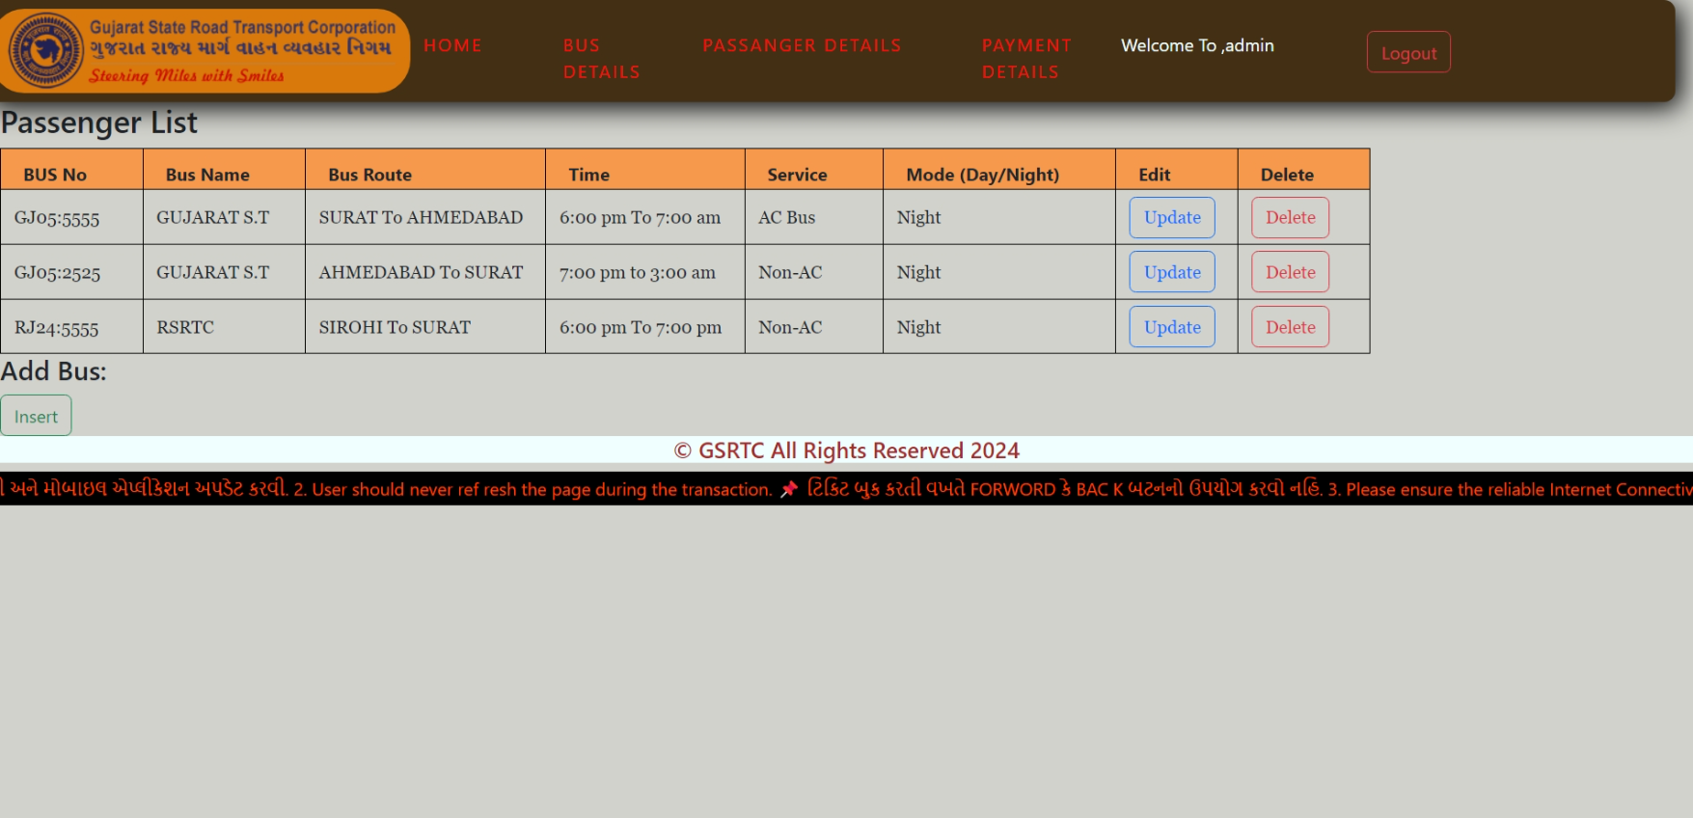

5.1.6 Admin Passanger Details Page

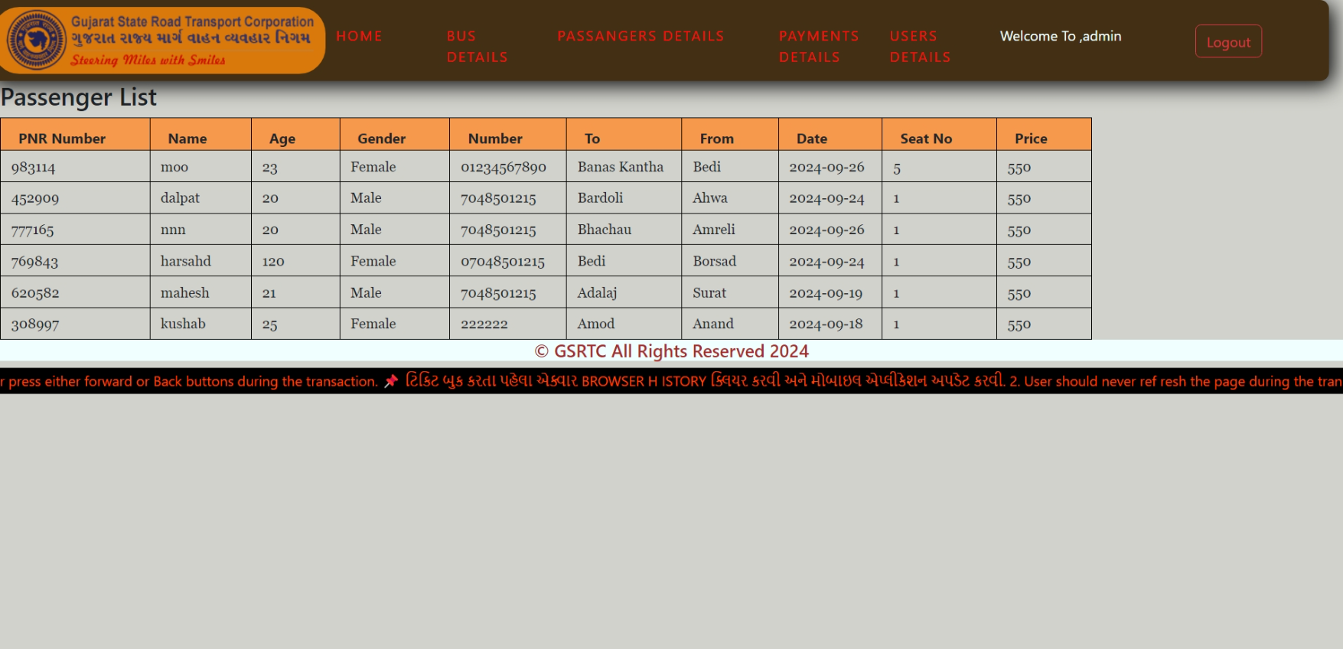

5.1.7Admin Payment Details Page

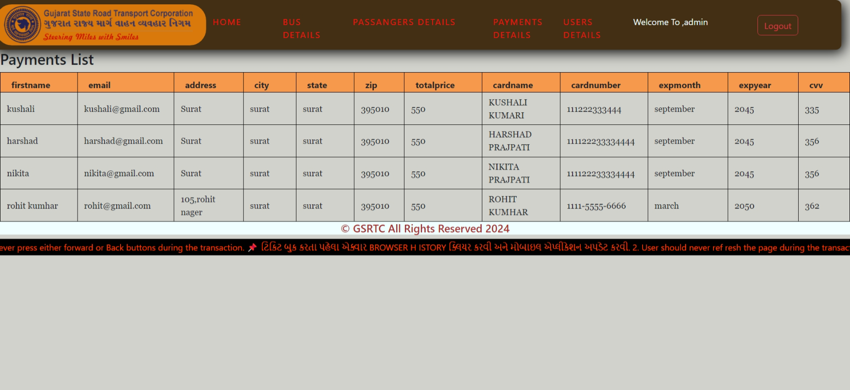

5.1.8 Admin User Details Page

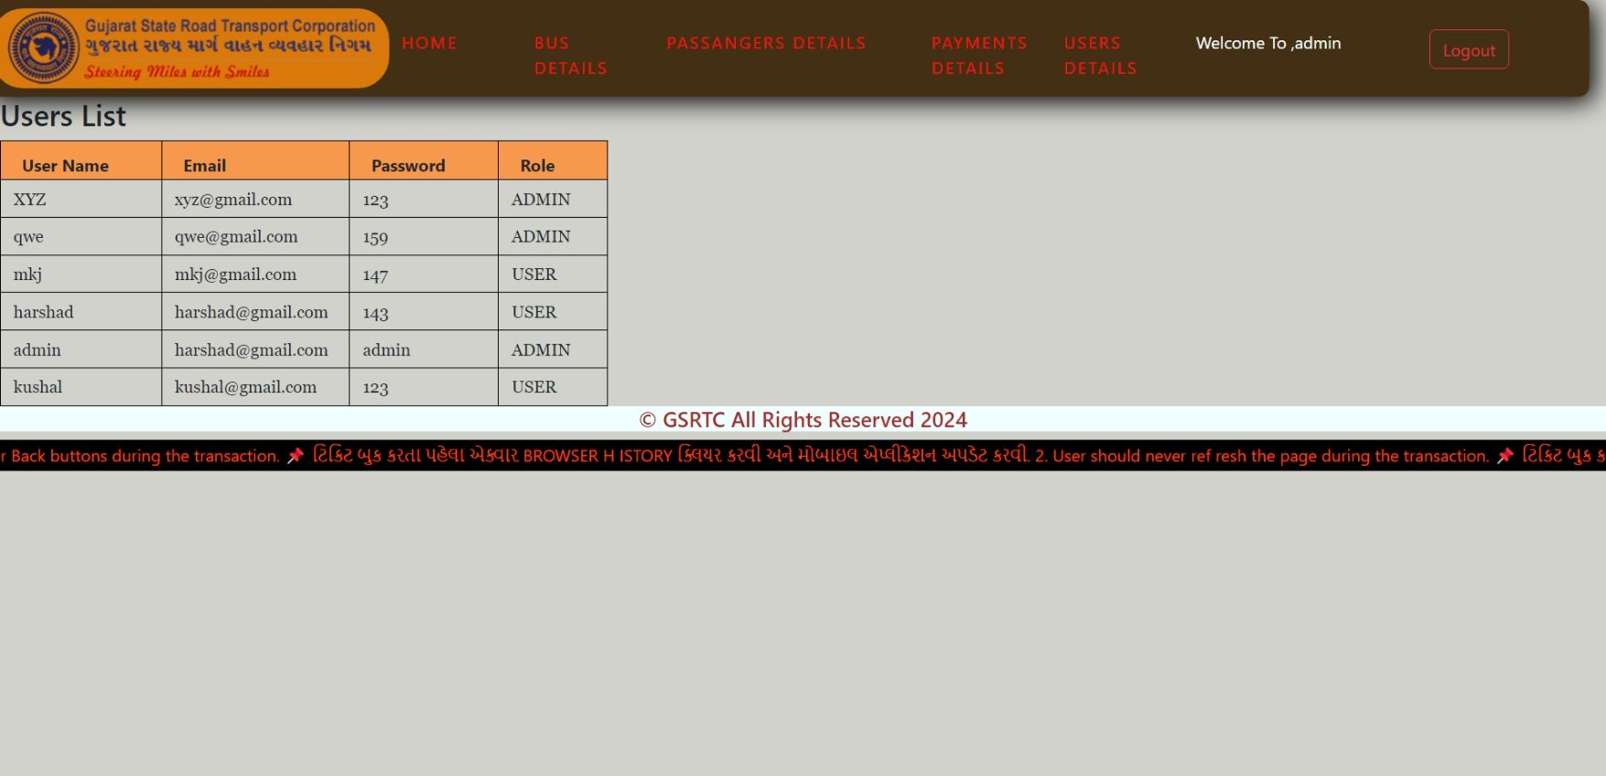

5.1.9 Admin Add Bus Page

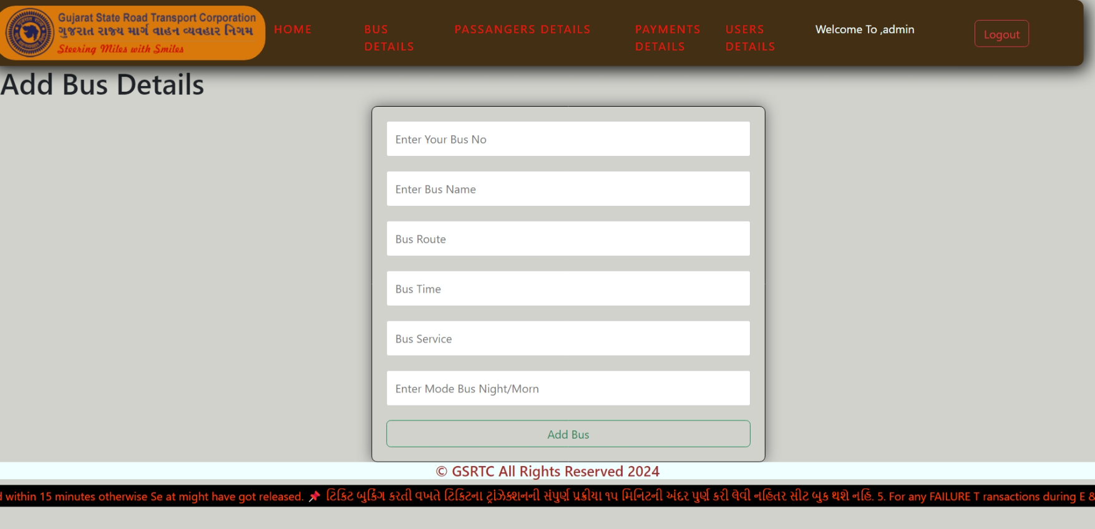

5.1.10 Admin Update Bus Page

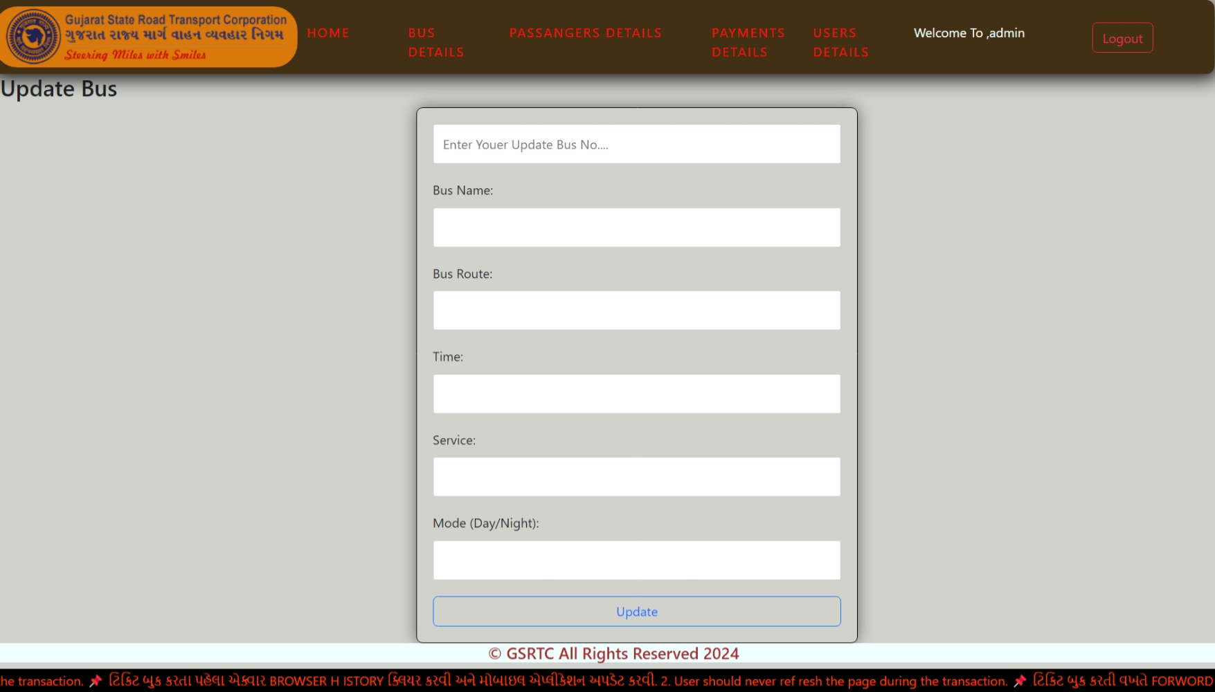

5.1.10 Admin Delete Bus Page

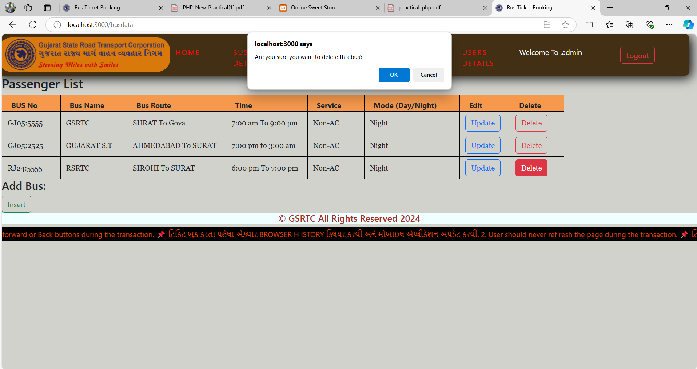

**5.2Client Side**

5.2.1 Client Login

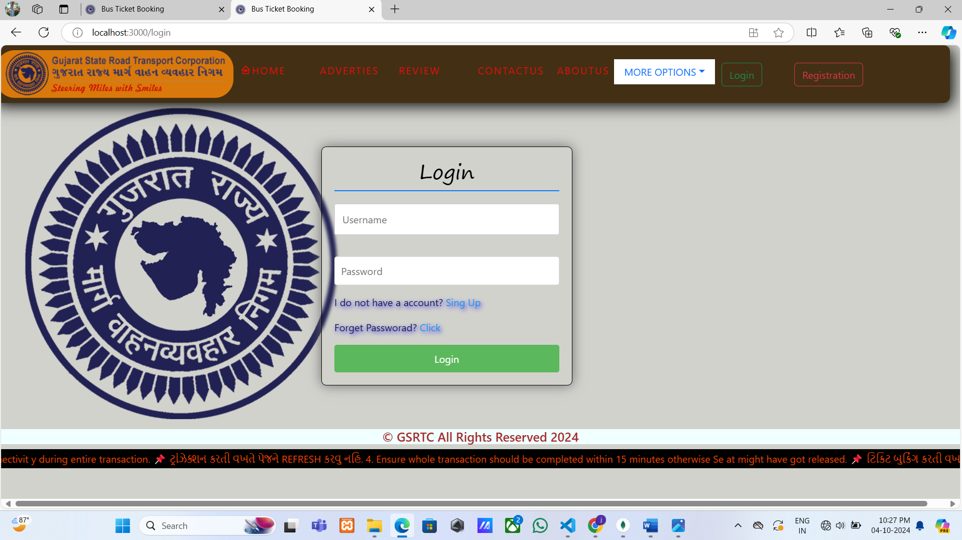

5.2.2 Client Registration

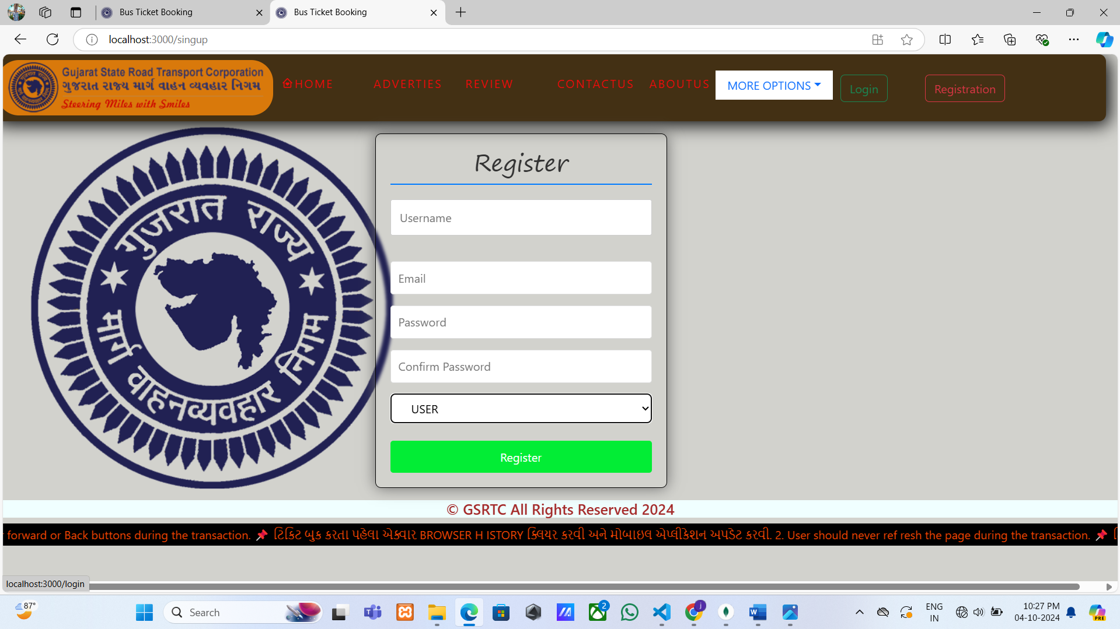

5.2.3 Client Home Page

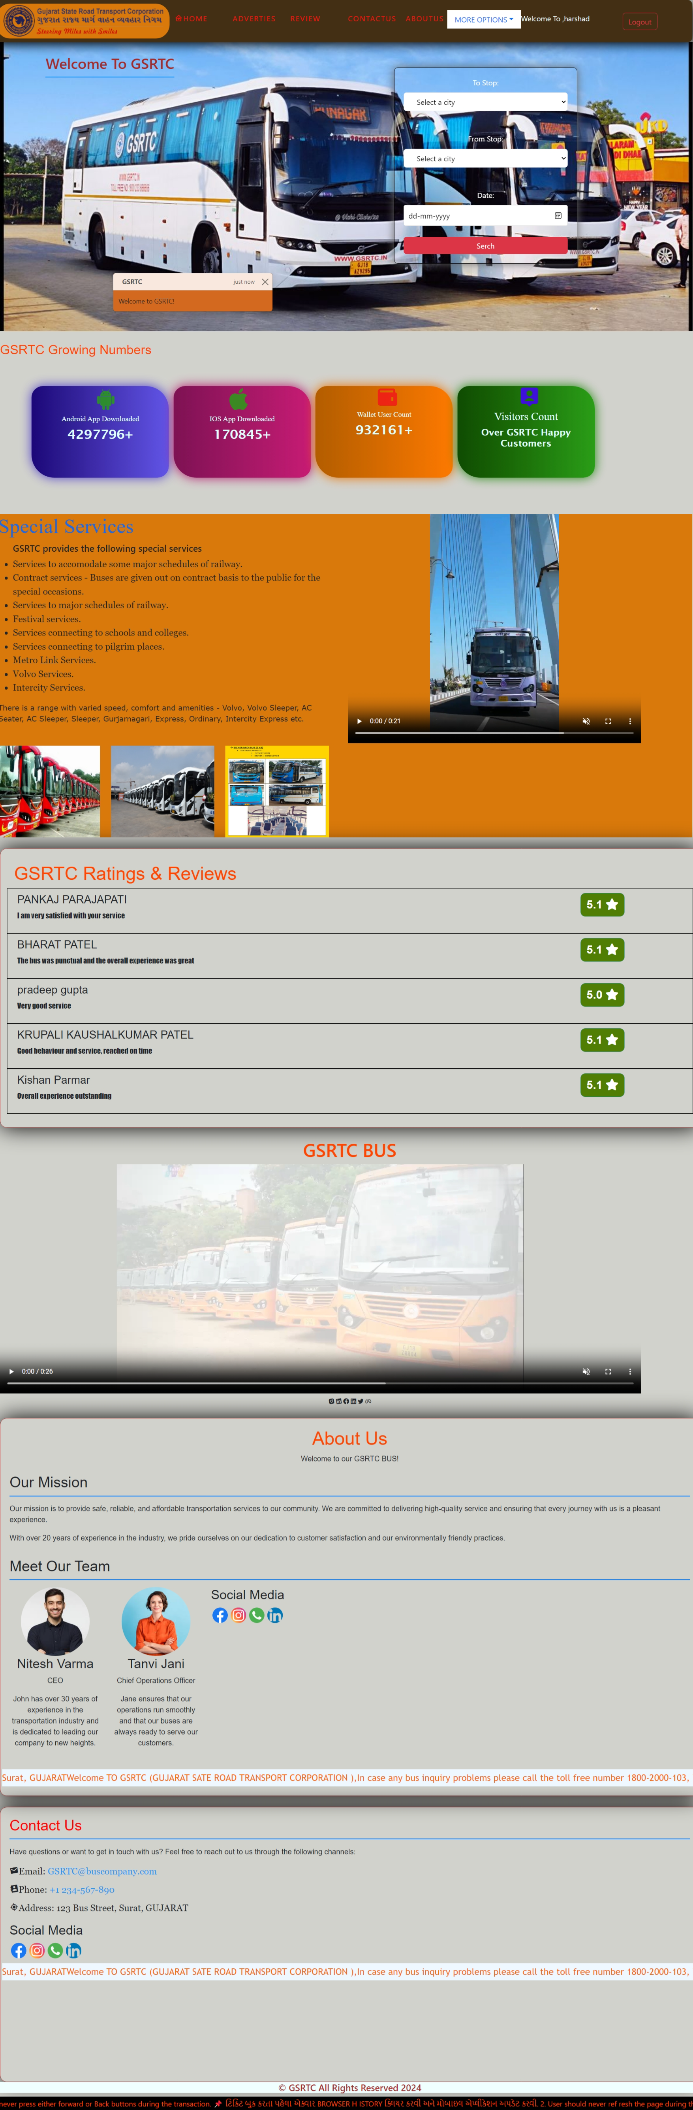

5.2.4 Client Profile Page

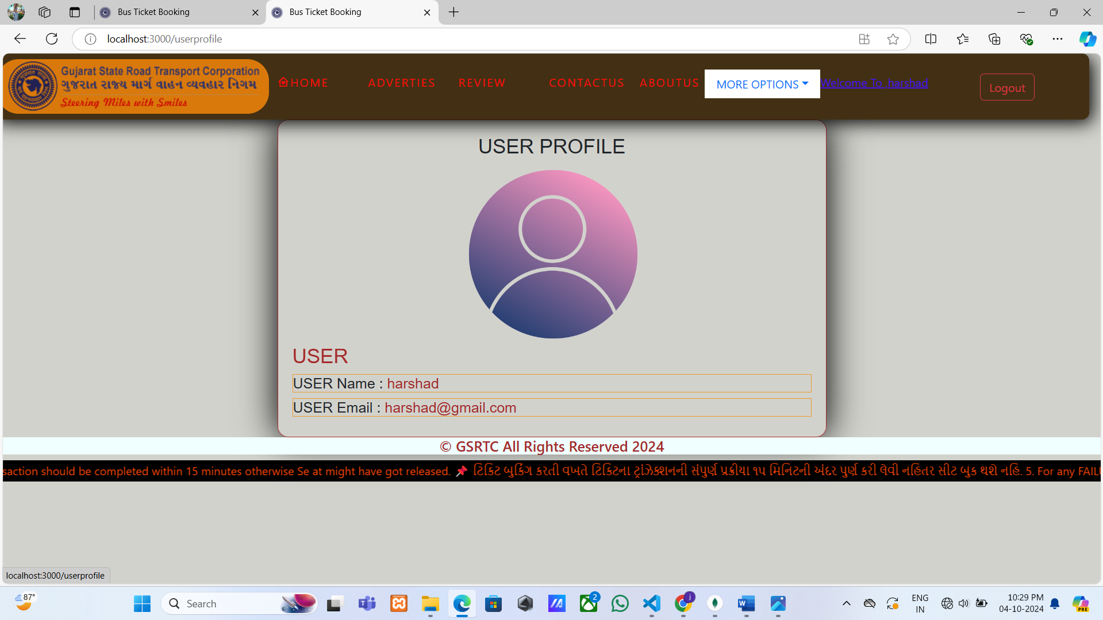

5.2.5 Client Forget Password Page

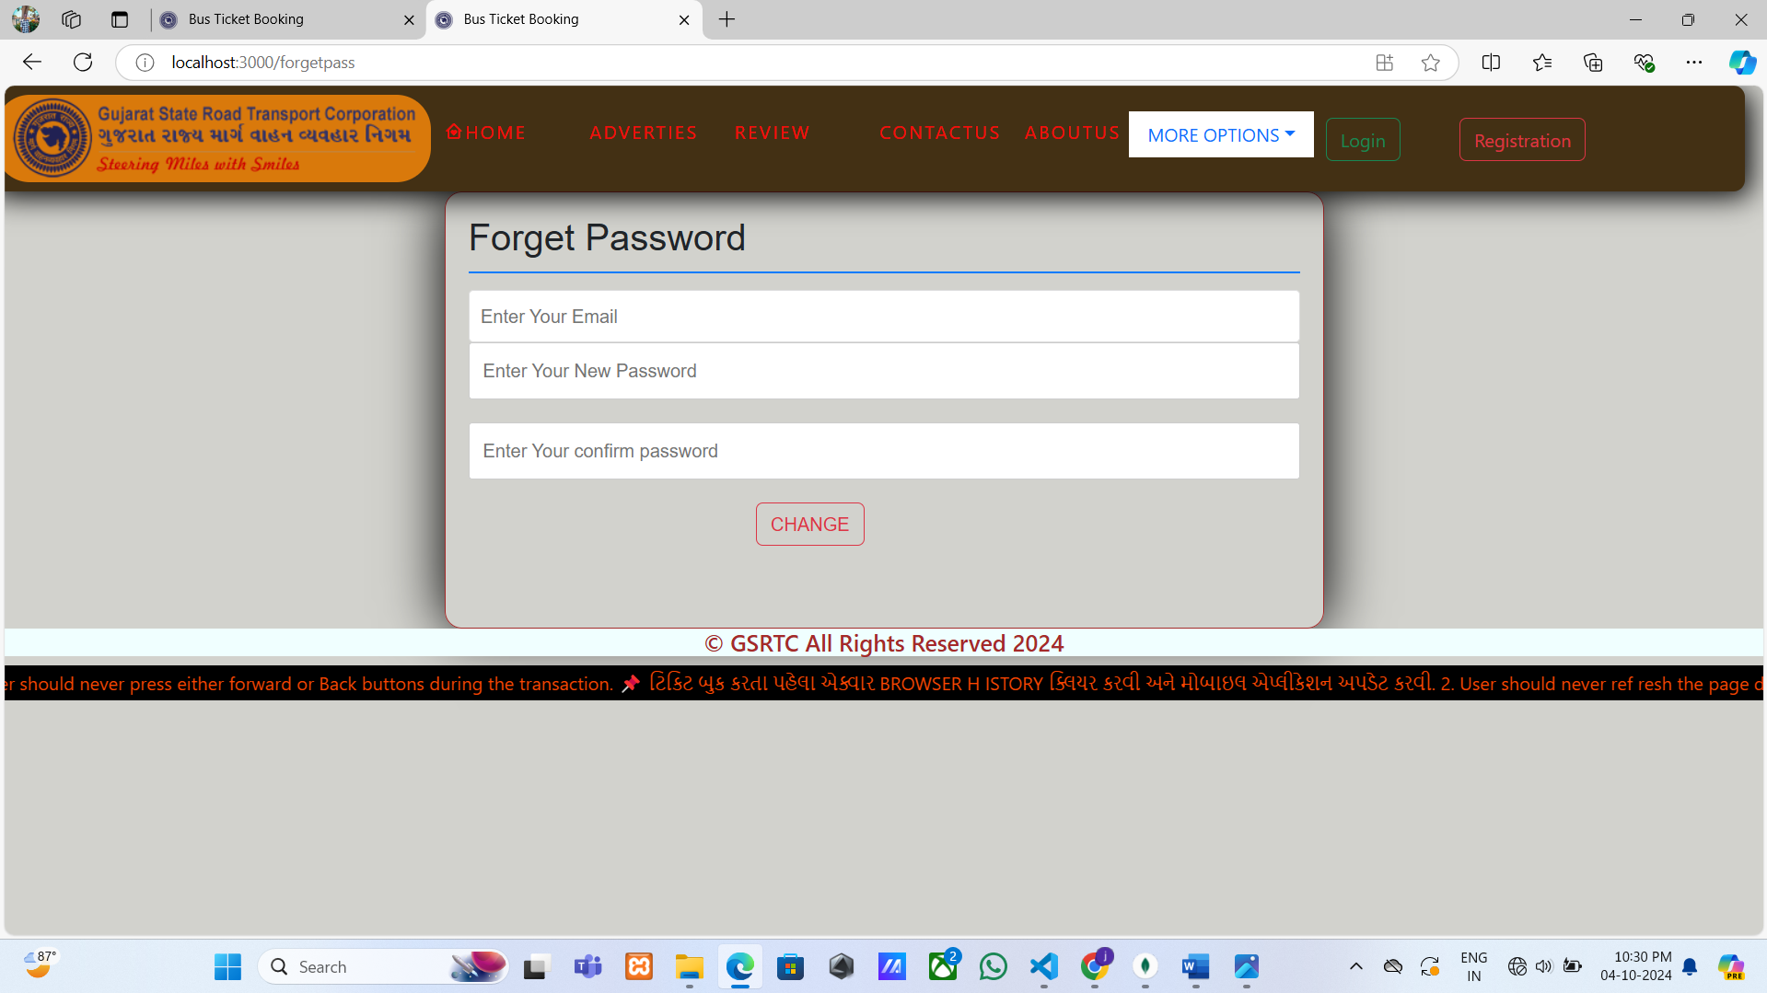

5.2.6 Client Search Ticket Page

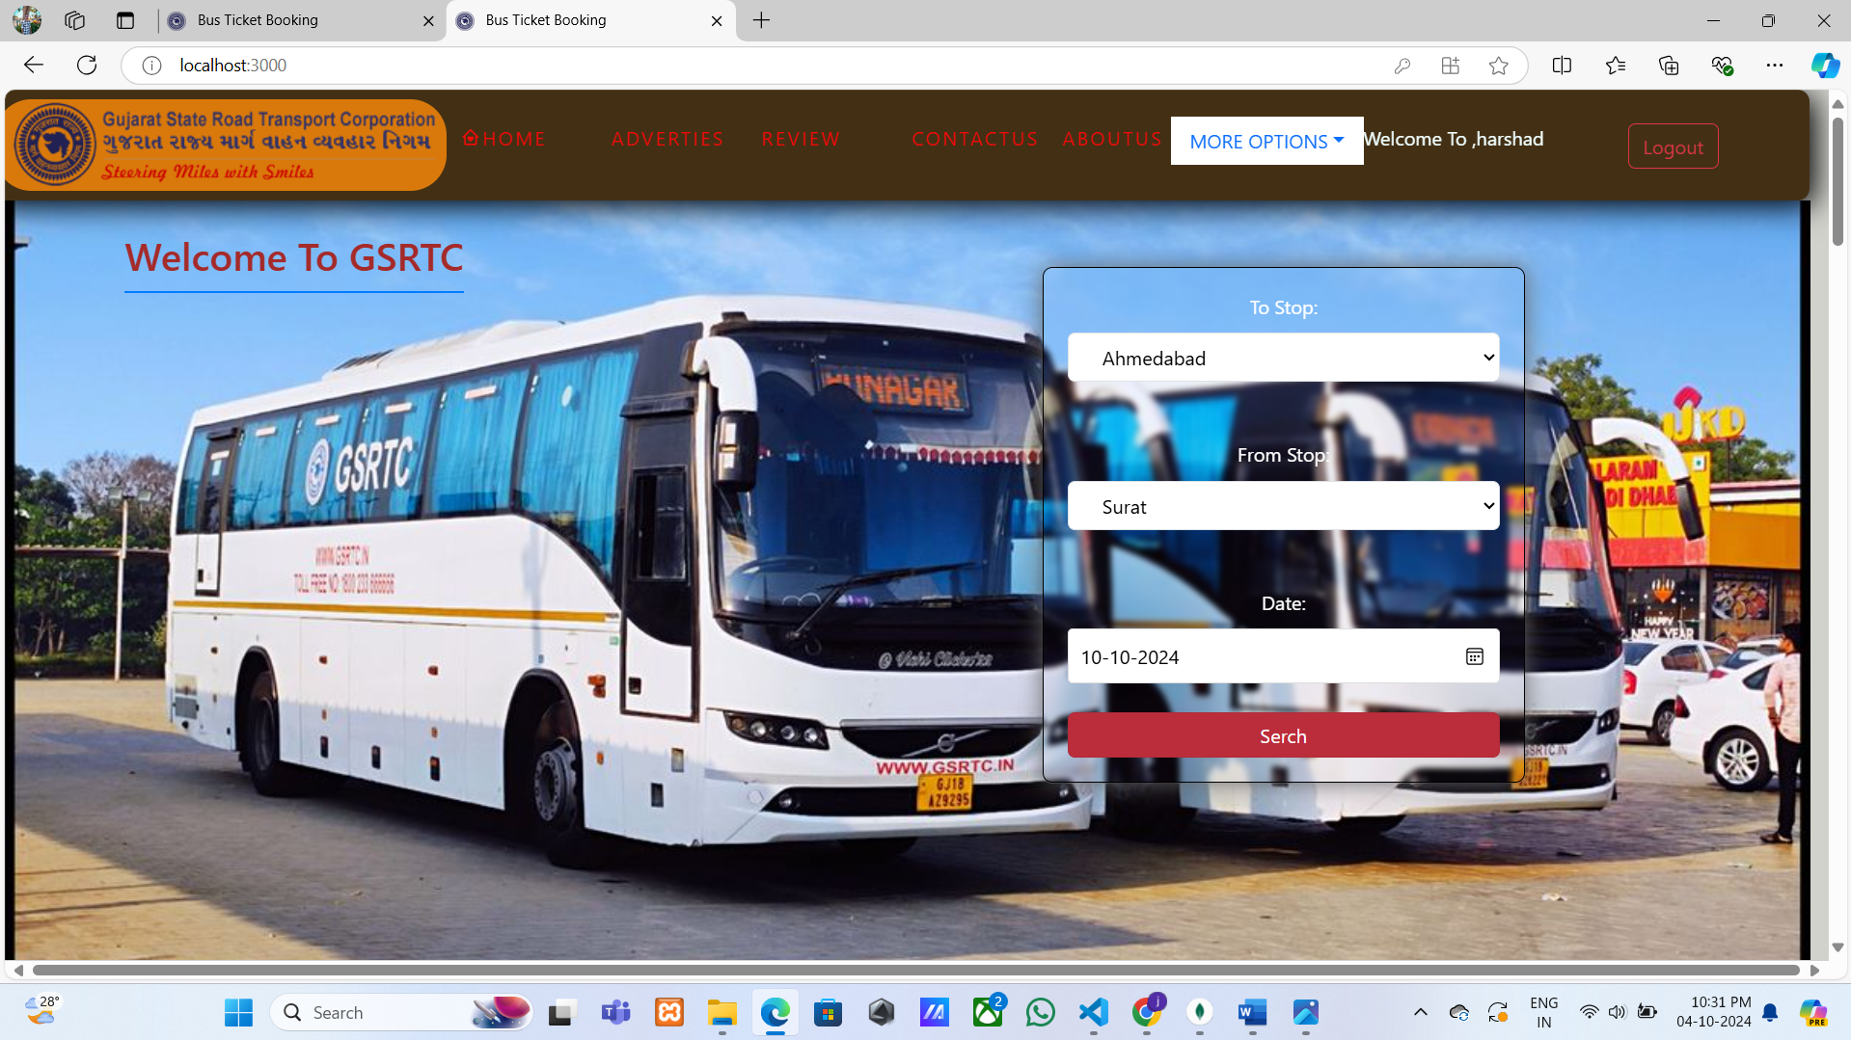

5.2.7 Client Available Bus Page

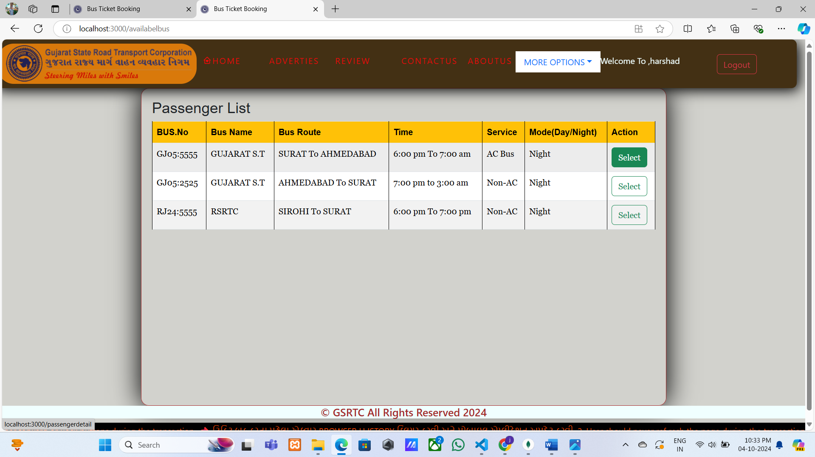

5.2.8 Client Passanger Details Page

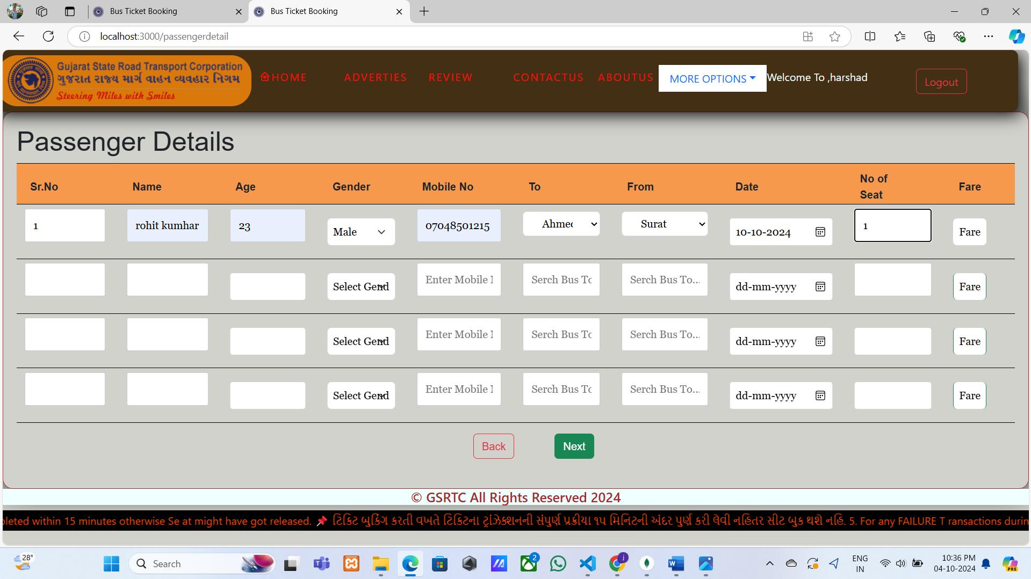

5.2.9 Client Seat Layout Page

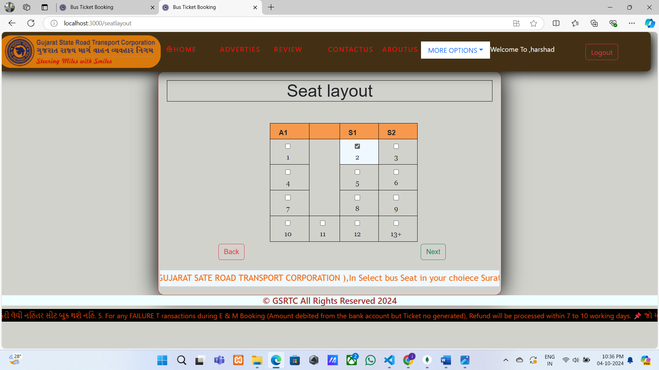

5.2.10 Client Payment Page

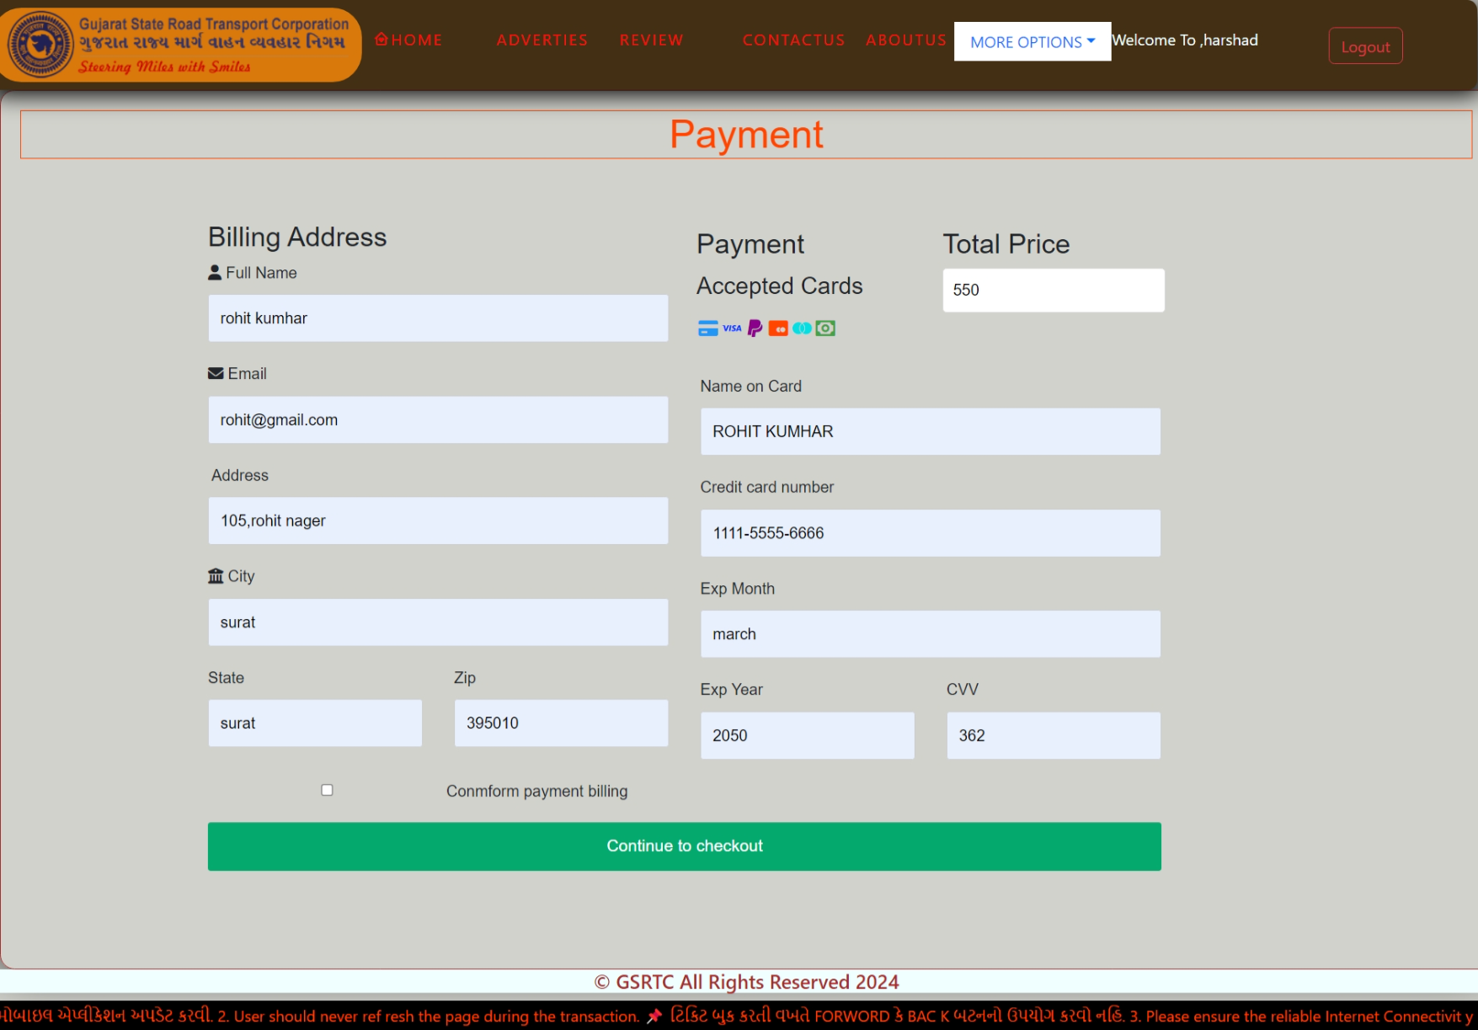

5.2.11 Client Ticket Layout Page

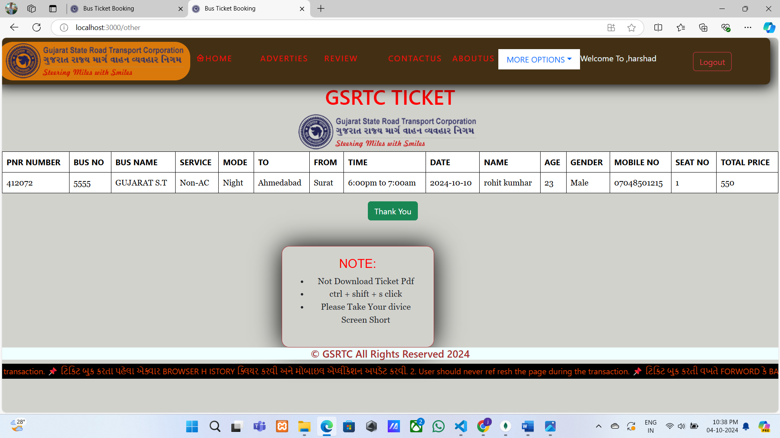

5.2.12 Client Download Ticket Page

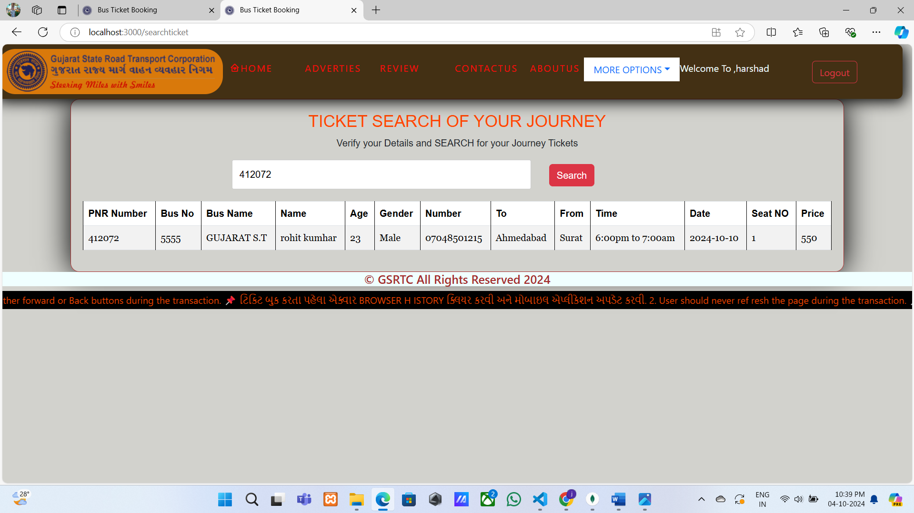

5.2.13 Client Cancel Ticket Page

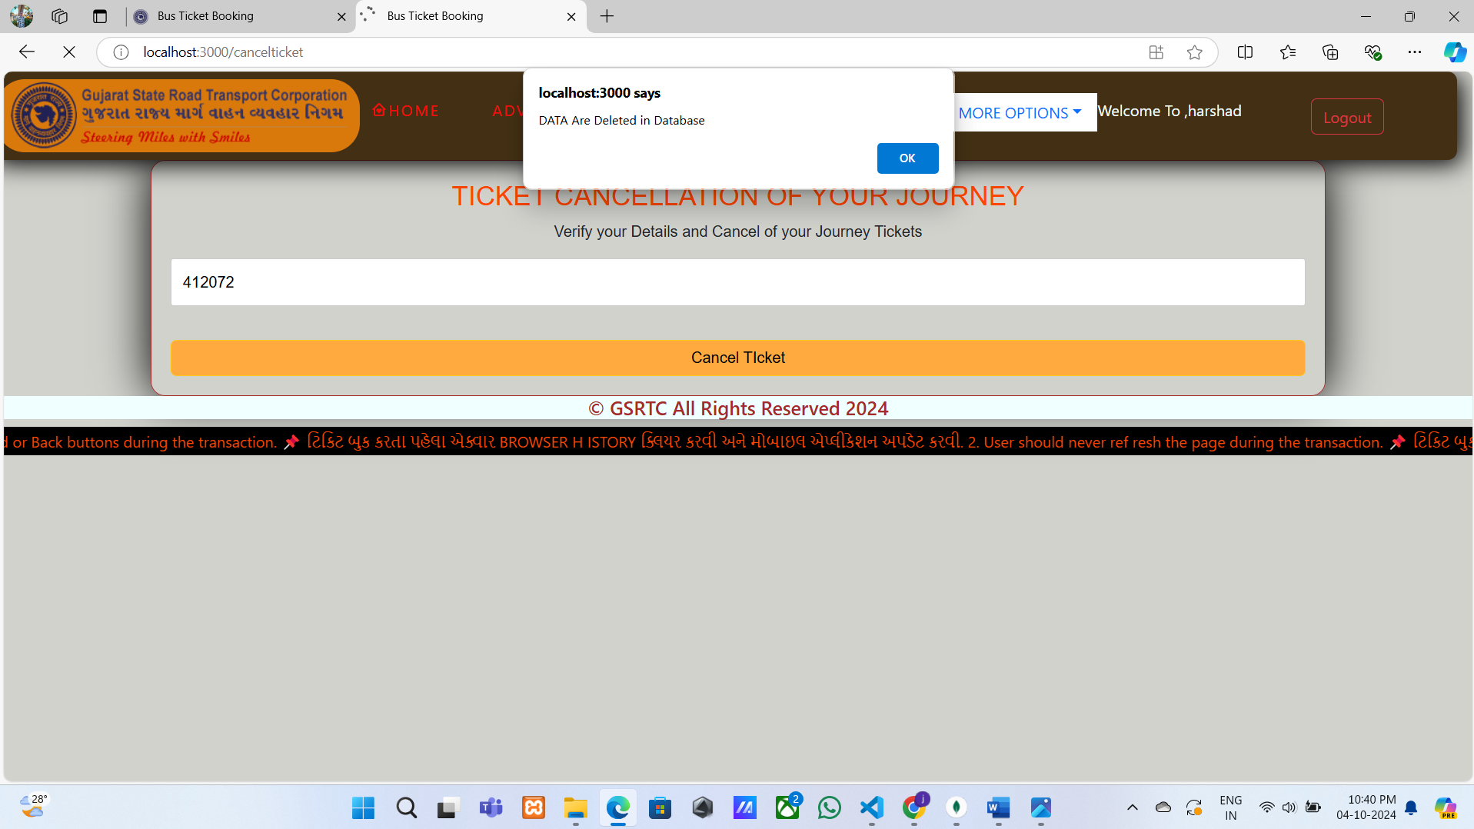

5.2.14 Client Adverties Page

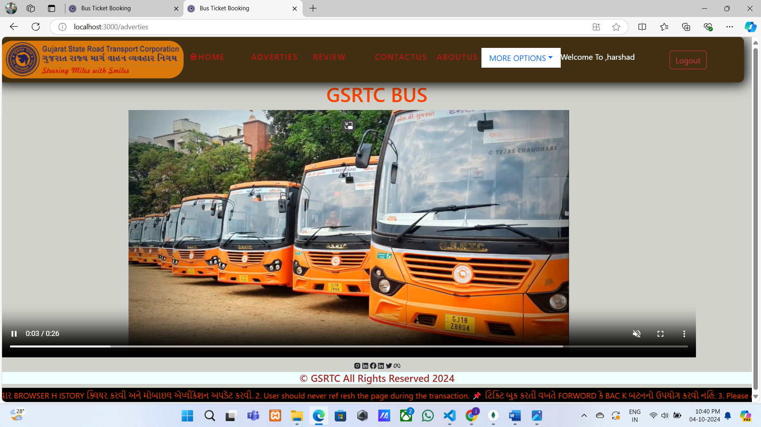

5.2.15 Client Number Growing Page

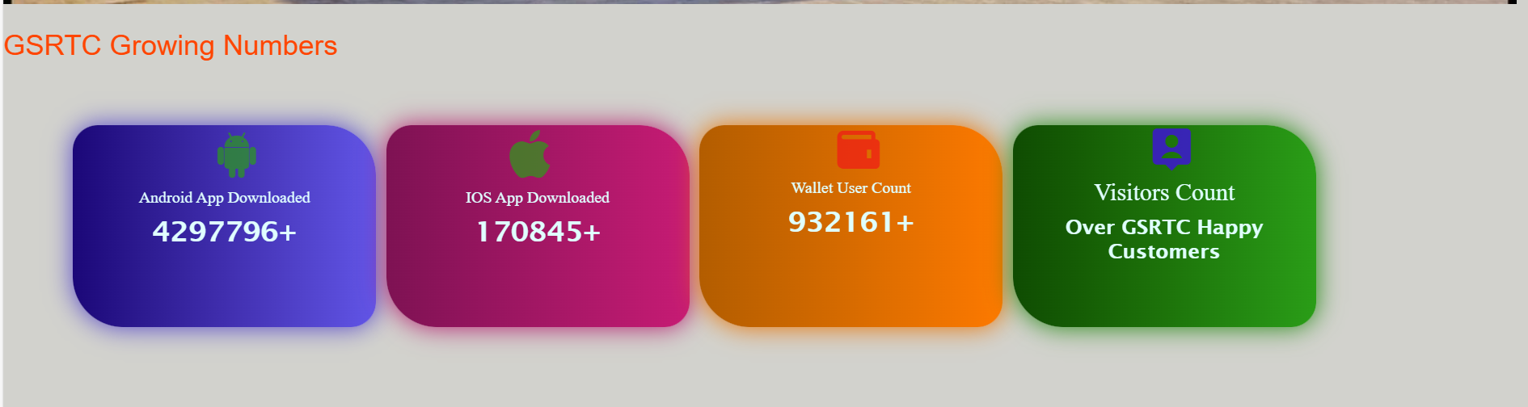

5.2.16 Client FAQ Page

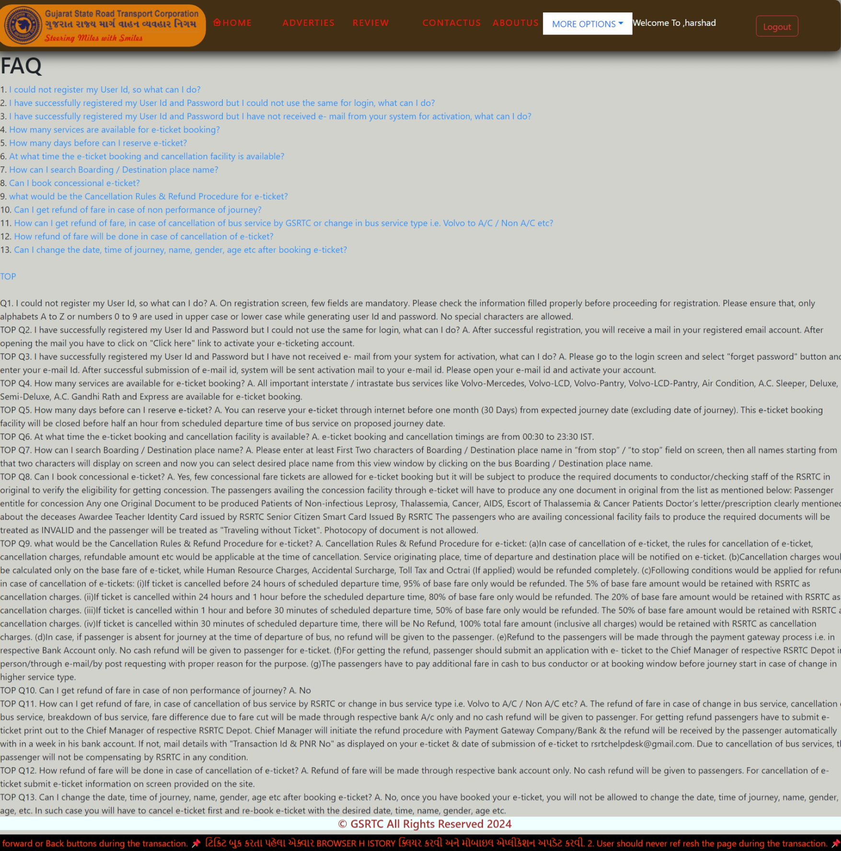

5.2.17 Client Service Page

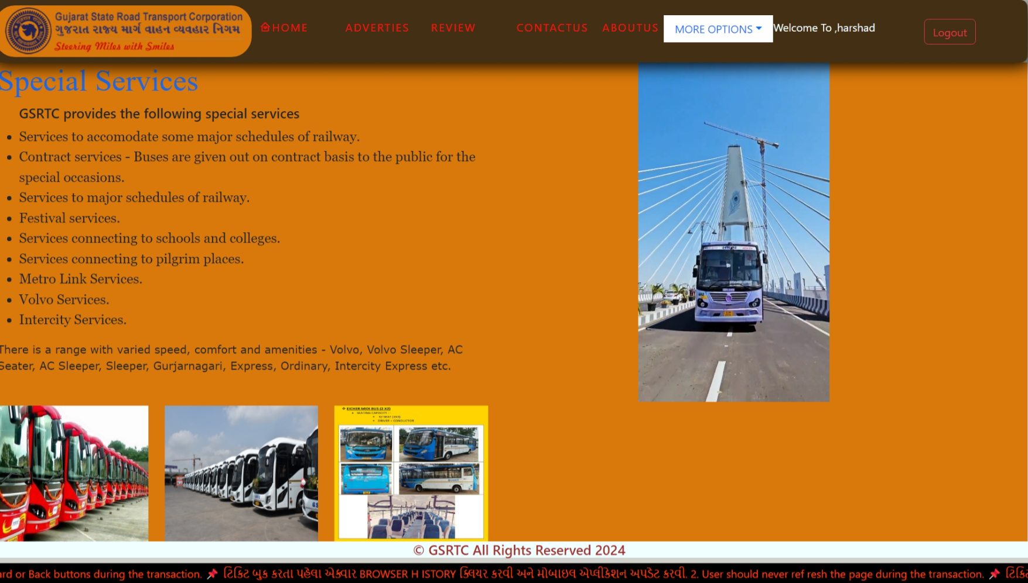

5.2.18 Client Privacy & Policy Page

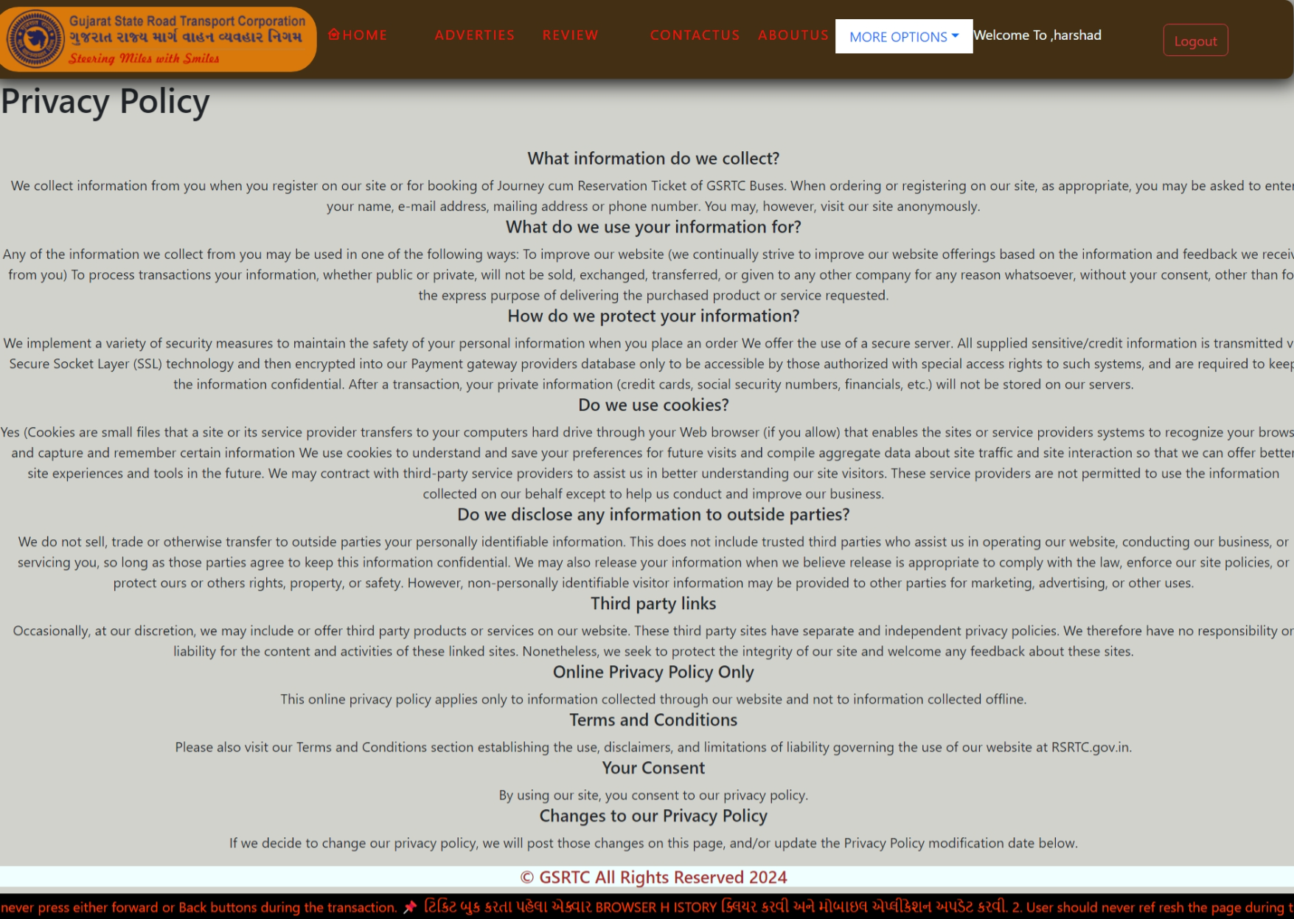

5.2.19 Client Terms & Condition Page

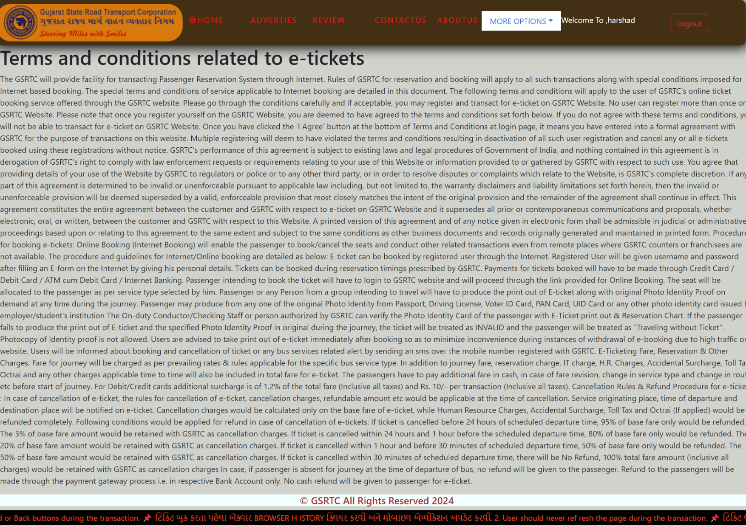

5.2.20 Client Review Page

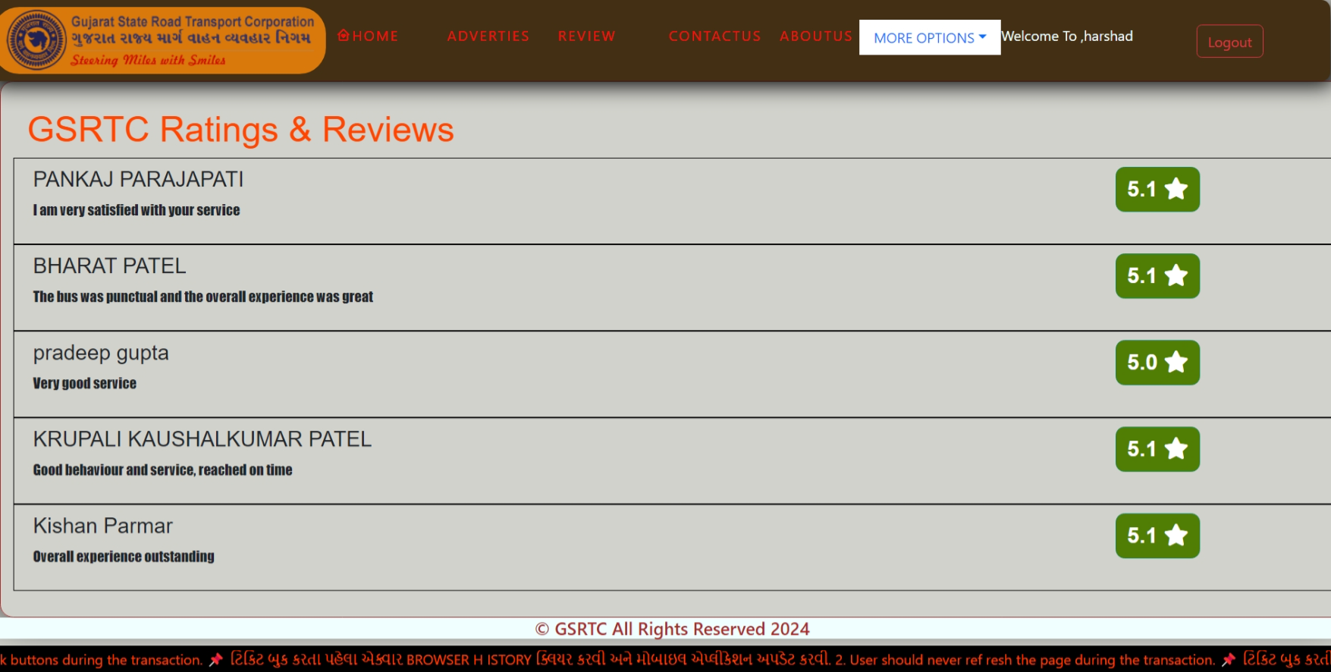

5.2.21 Client About Us Page

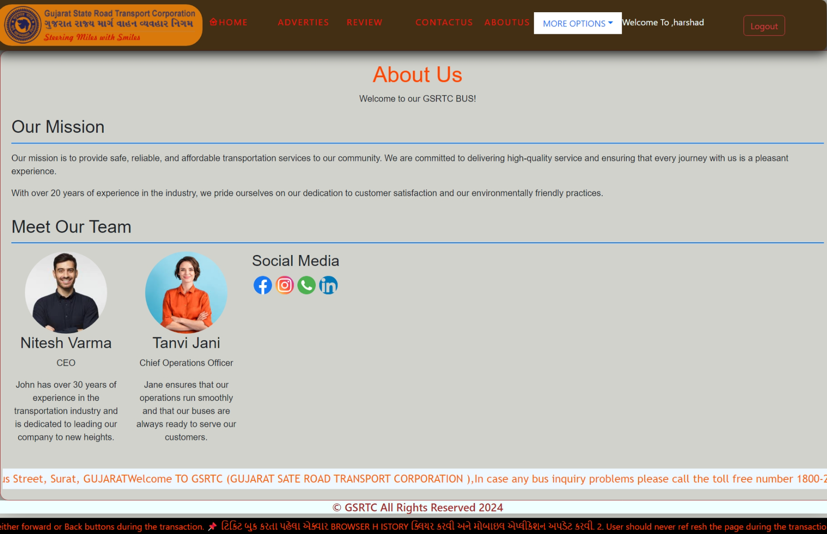

5.2.21 Client Contact Us Page

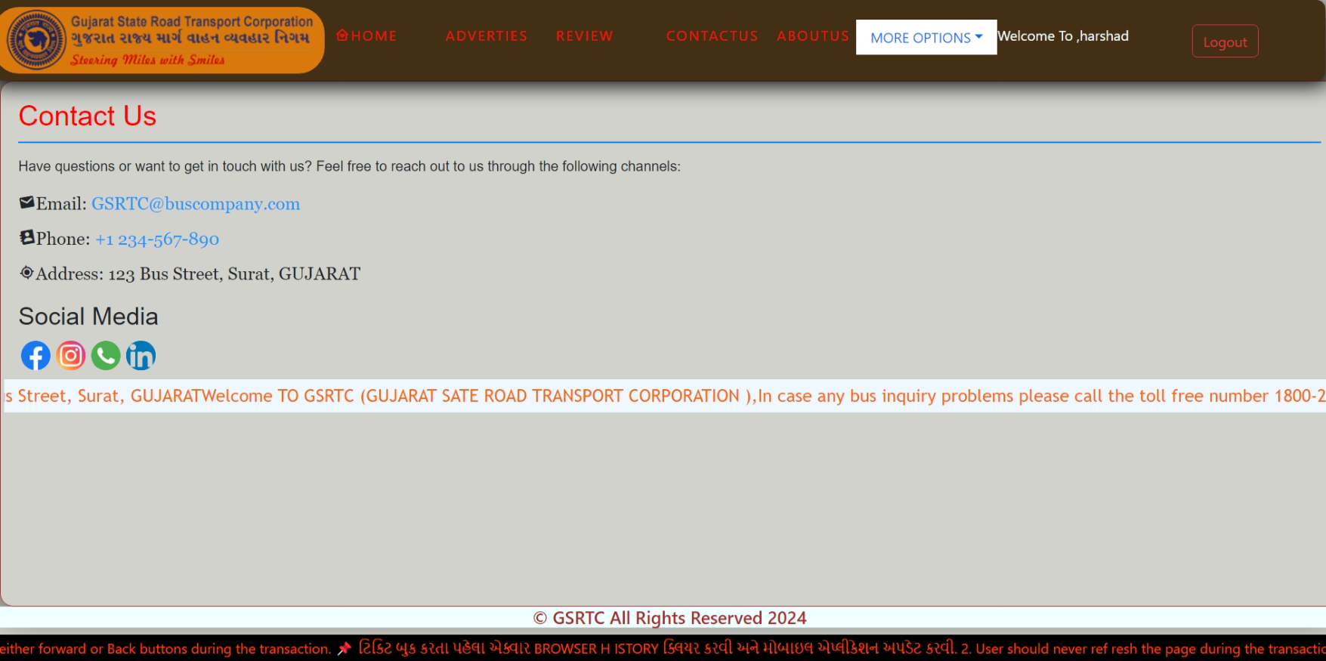

**5.3Visitor Side:**

5.3.1 Visitor Home Page

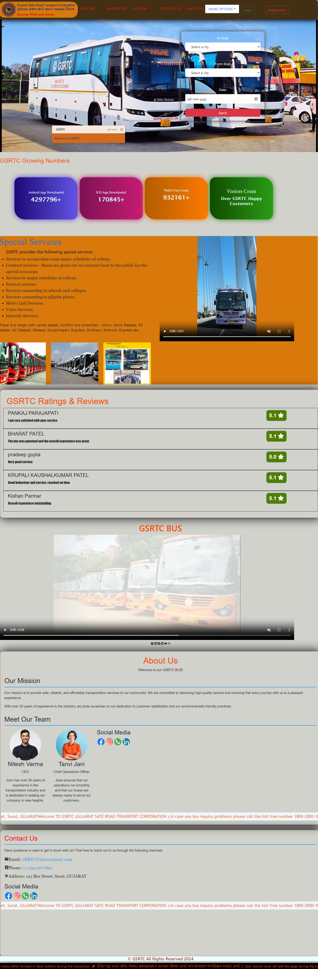

5.3.2 Visitor Adverties Page

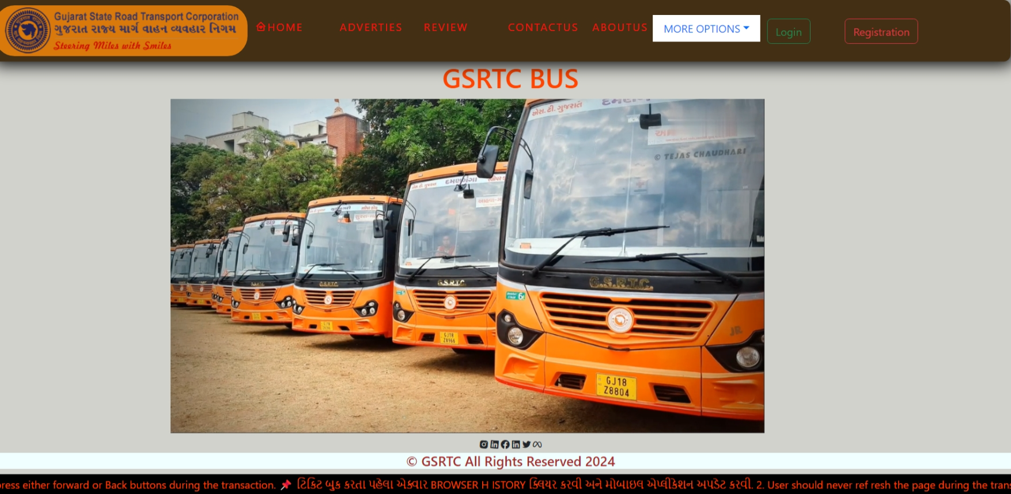

5.3.3 Visitor Review Page

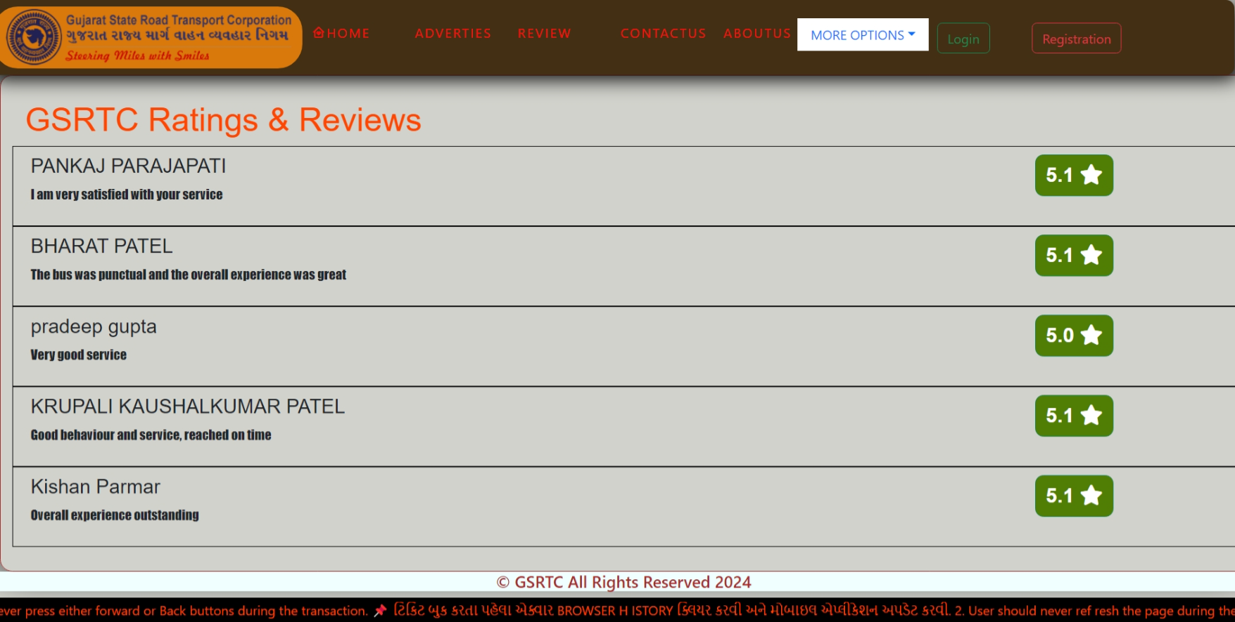

5.3.4 Visitor Terms & Condition Page

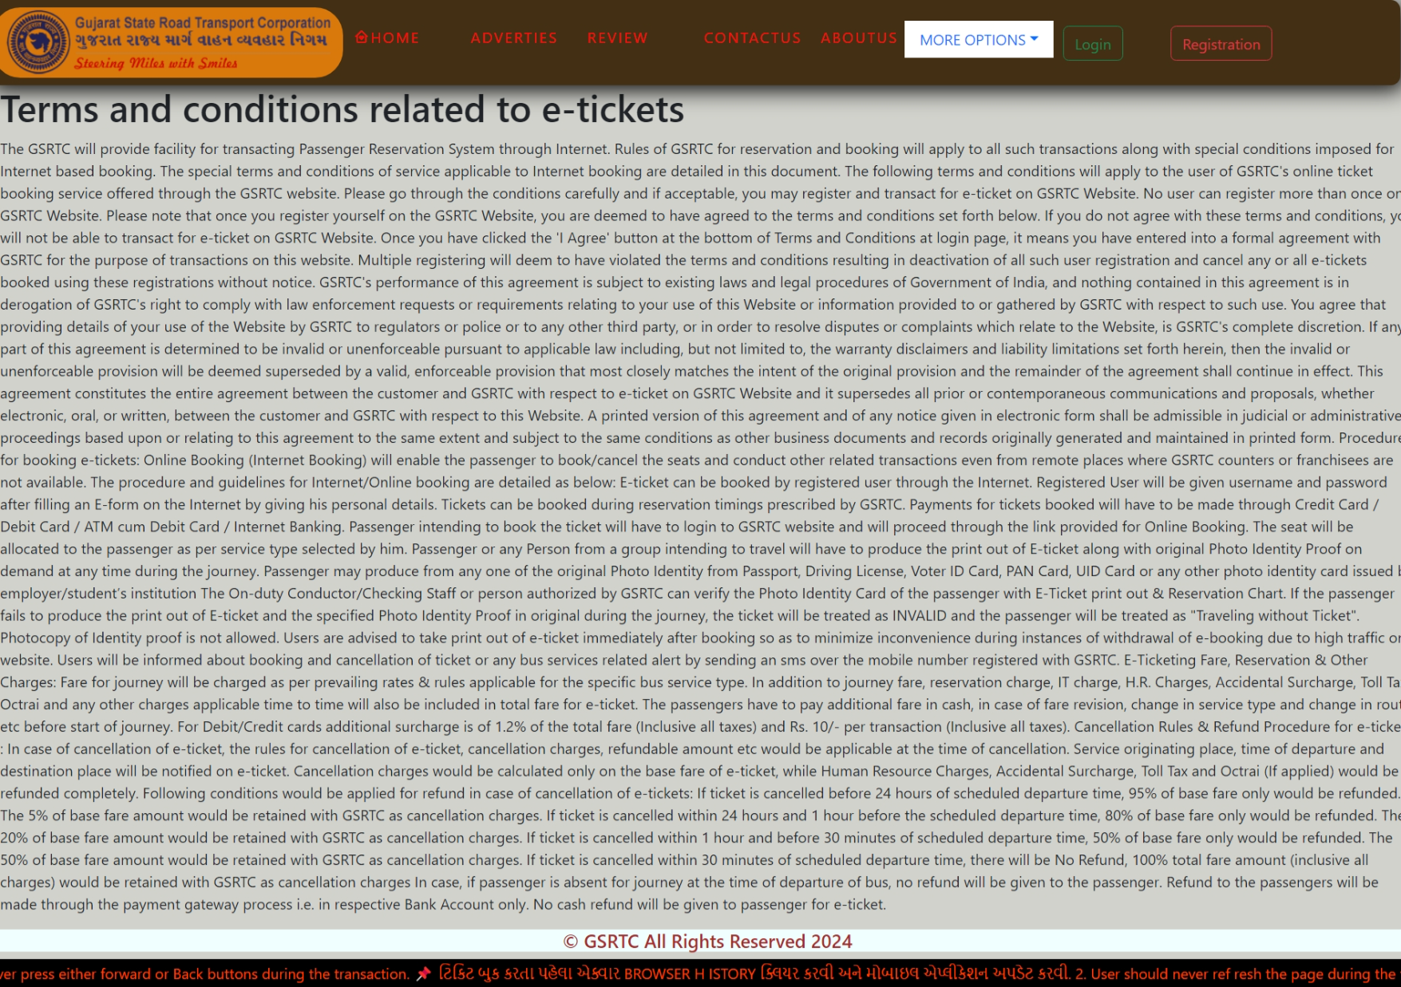

5.3.5 Visitor Privacy Policy Page

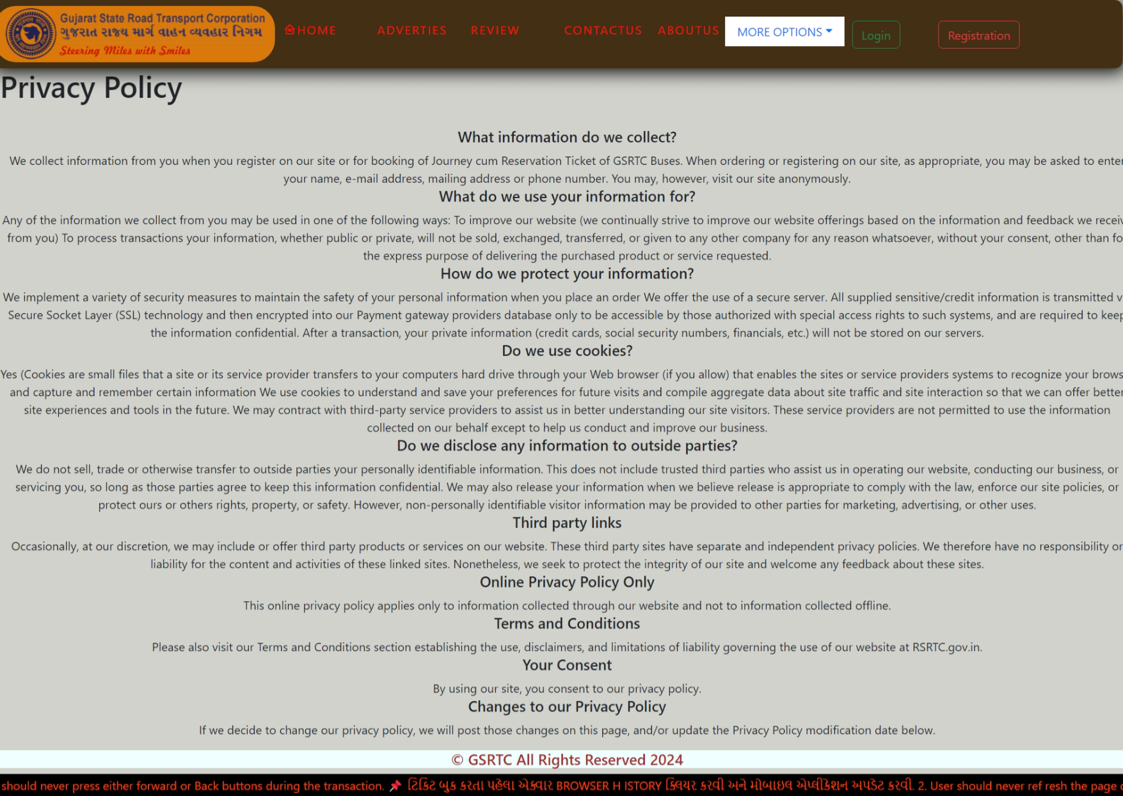

5.3.6 Visitor FAQ Page

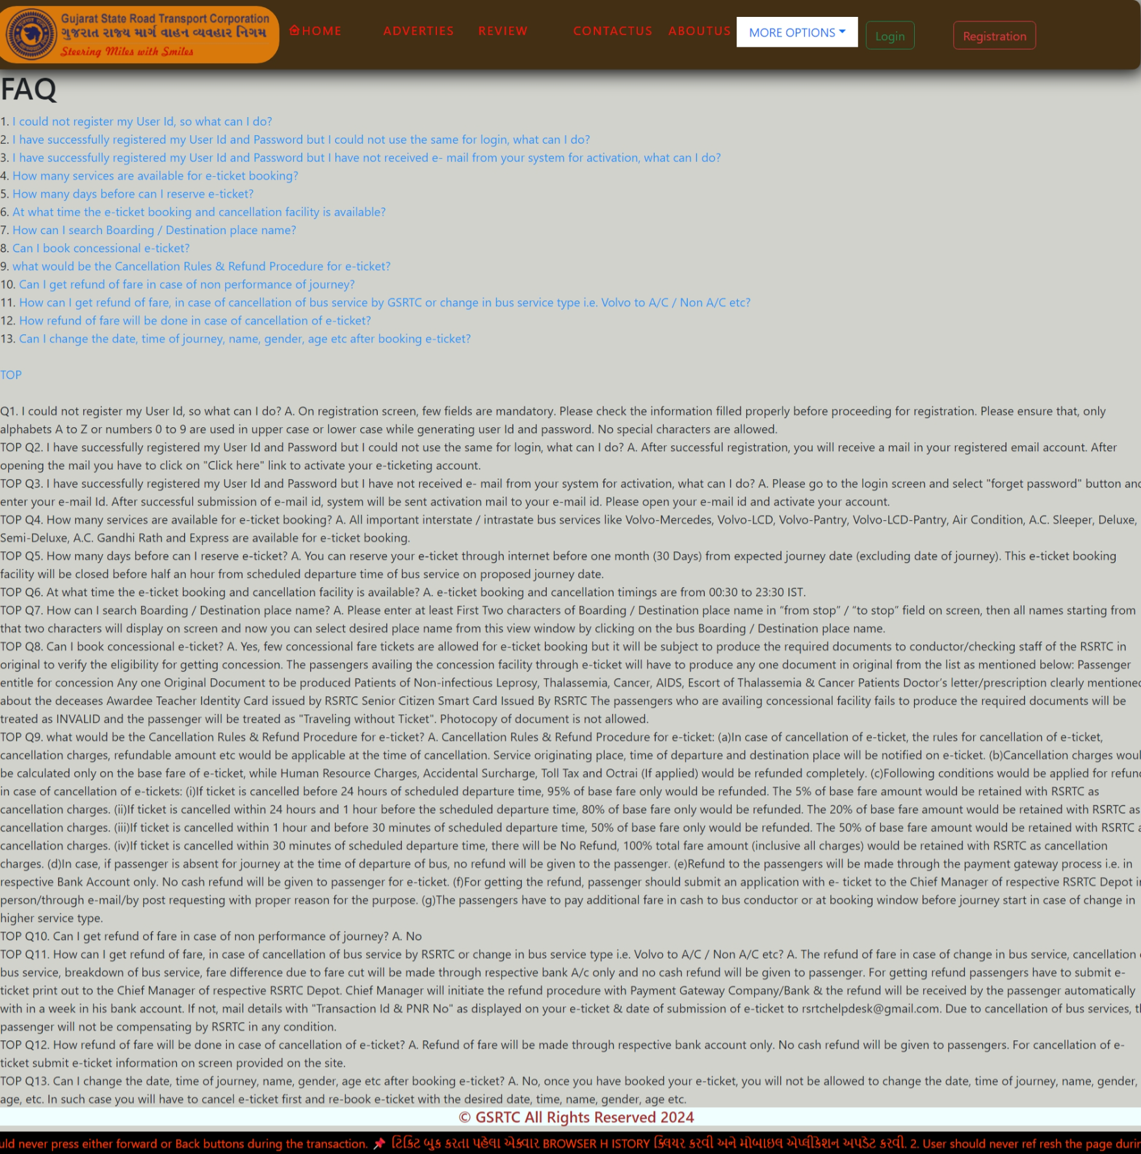

5.3.7 Visitor Service Page

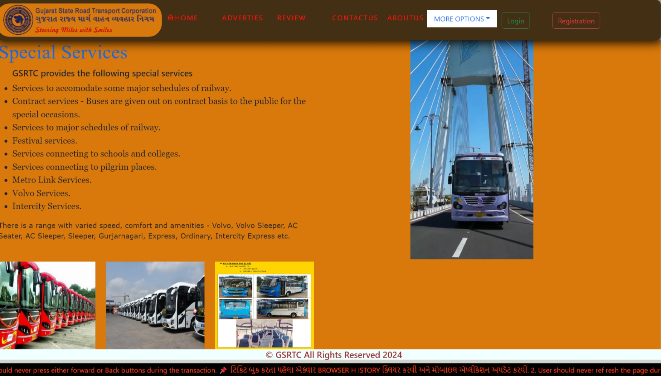

5.3.8 Visitor Contact Us Page

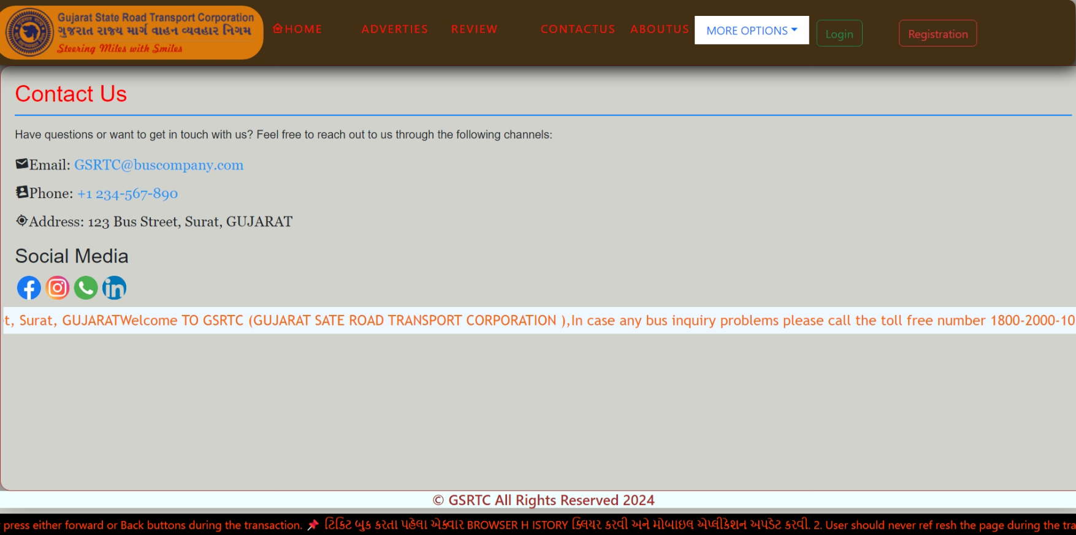

5.3.9 Visitor About Us Page

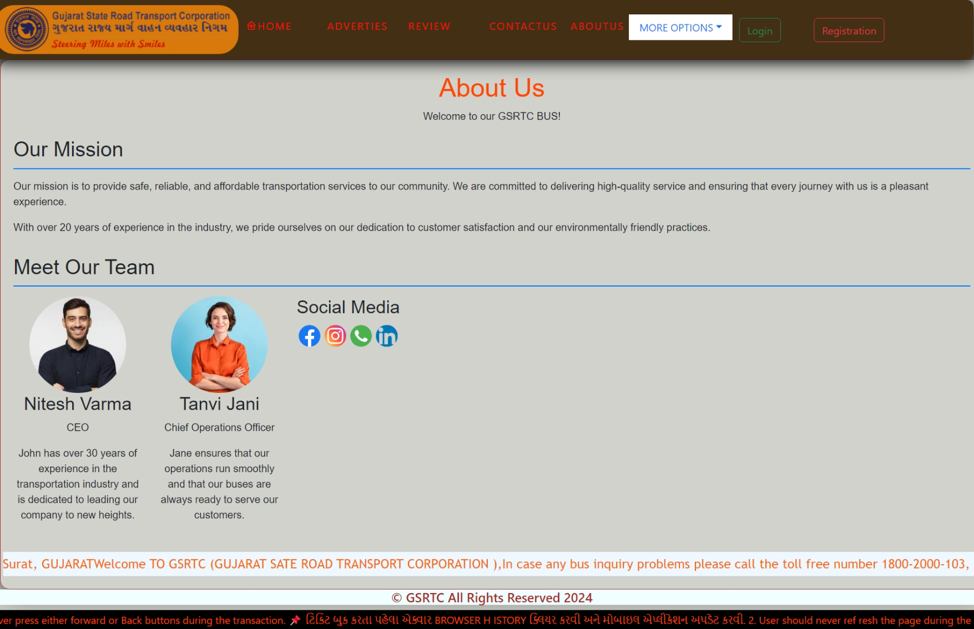

1. **Conclusion**

**Conclusion**

* + In conclusion, the **Bus Ticket Booking System** provides a streamlined and user-friendly platform that enhances the travel experience for passengers. The system addresses the common challenges faced in traditional ticket booking methods by integrating advanced features such as real-time seat availability, secure payment processing, and user-friendly navigation.
  + The Bus Ticket Booking System will evolve with technological advancements, potentially integrating features like mobile ticketing, loyalty programs, and AI-driven customer support.
  + The system aims to remain a leading solution in the transportation sector by continually seeking user feedback and adapting to market trends.
  + Overall, the successful implementation of this system will not only enhance operational efficiency for bus companies but also improve customer satisfaction, fostering loyalty and encouraging repeat business.

1. **Bibliography**

Bibliography :

* 1. React Js:

<https://react.dev>

* 1. Node Js:

https://nodejs.org/en/learn/getting-started/introduction-to-nodejs

* 1. Express Js:

https://expressjs.com

* 1. Mongo DB:

https://www.mongodb.com/products/platform/atlas-database

* 1. YouTube:

https://www.youtube.com

* 1. Google:

<https://www.google.com>

* 1. Boxicons:

<https://boxicons.com>

* 1. Video Editor:

<https://www.flexclip.com>

* 1. W3School:

<https://www.w3schools.com>

* 1. Chat AI:

https://openai.com/index/chatgpt